Module 4 – Introduction to DBMS

Introduction to SQL

Theory Questions:

1. What is SQL, and why is it essential in database management?

Ans. SQL is a (structured query language).

SQL is a standard language for storing, manipulating and retrieving data in databases.

SQL allows you to access and manipulate the databases.

why is it essential in database management:

1. Data Organization and Storage.
2. Efficient Data Retrieval.
3. Data Integrity.
4. Security and Access Control.
5. Data Analysis and Reporting.

2. Explain the difference between DBMS and RDBMS.

Ans.

|  |  |
| --- | --- |
| RDBMS | DBMS |
| The data stored is in table format. | The data stored is in the file format. |
| Data in the form of a table are linked together. | No connection between data. |
| Support distributed database. | No support for distributed databases. |
| Data is stored in a large amount. | The data stored is a small quantity. |
| RDBMS supports multiple users. | DBMS supports a single user. |
| The software and hardware requirements are higher. | The software and hardware requirements are low. |
| Example: Oracle, SQL Server. | Example: XML, Microsoft Access. |

3. Describe the role of SQL in managing relational databases.

Ans.

the key roles SQL plays in relational database management:

SQL is crucial in managing relational databases by providing a standardized way to interact with data.

It is used for:

1. Data Definition (DDL - Data Definition Language):

Creating, modifying, and deleting database structures such as tables, indexes, and schemas.

Commands: CREATE, ALTER, DROP.

1. Data Manipulation (DML - Data Manipulation Language):

Inserting, updating, and deleting data stored in tables.

Commands: INSERT, UPDATE, DELETE.

1. Data Retrieval (DQL - Data Query Language):

Fetching data from the database using filtering, sorting, and aggregation queries.

Command: SELECT.

1. Data Control (DCL - Data Control Language):

Managing user permissions and access control.

Commands: GRANT, REVOKE.

1. Transaction Control (TCL - Transaction Control Language):

Ensuring data integrity and consistency during transactions.

Commands: COMMIT, ROLLBACK, SAVEPOINT.

4. What are the key features of SQL?

Ans. The key features of SQL are:

1. Data Querying

Retrieve data using SELECT.

1. Data Manipulation

Insert, update, and delete data (INSERT, UPDATE, DELETE).

1. Data Definition

Create and modify database structures (CREATE, ALTER, DROP).

1. Data Control

Manage user access (GRANT, REVOKE).

1. Transaction Management

Ensure data consistency (COMMIT, ROLLBACK).

1. Integrity Constraints

Maintain data accuracy (PRIMARY KEY, FOREIGN KEY).

LAB EXERCISES:

Lab 1: Create a new database named school_db and a table called students with the following columns: student_id, student_name, age, class, and address.

Ans.

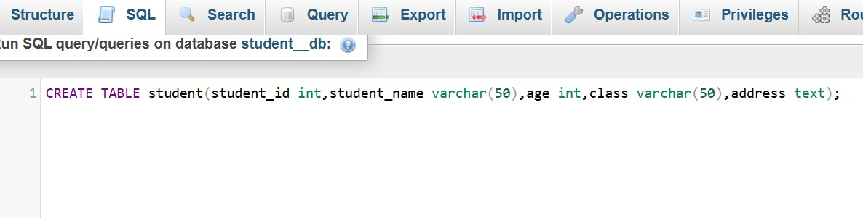

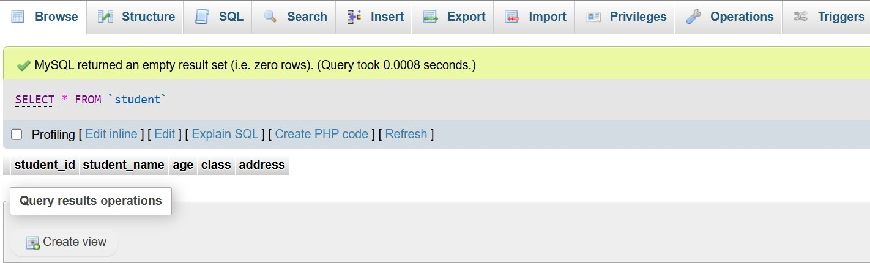

Lab 2: Insert five records into the student's table and retrieve all records using the SELECT statement.

Ans.

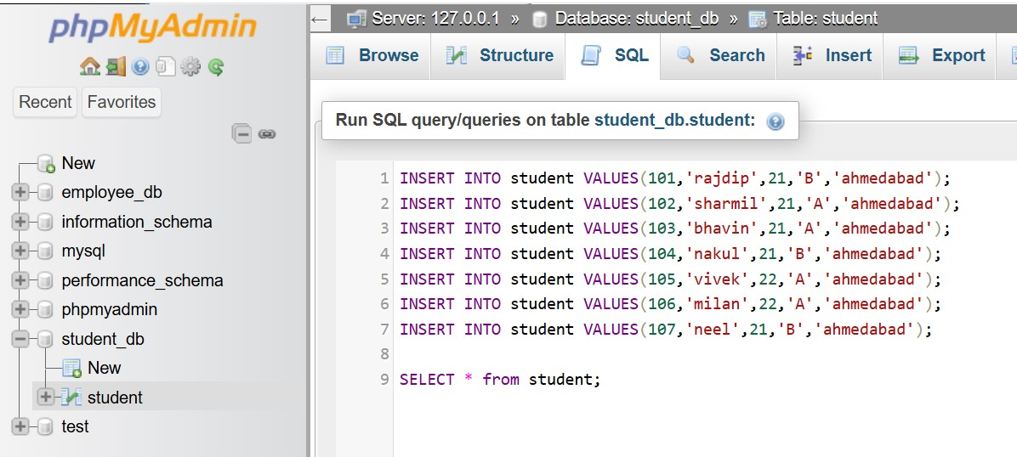

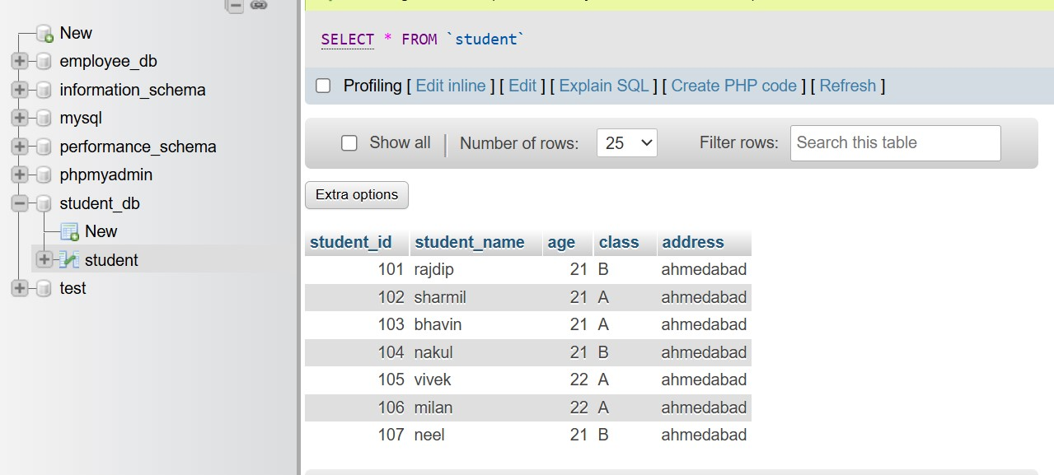

2. SQL Syntax

Theory Questions:

1. What are the basic components of SQL syntax?

Ans. The basic components of SQL syntax include:

1. **Statements**

Commands used to interact with the database (example: SELECT, INSERT, UPDATE, DELETE).

1. **Clauses**

Components of statements that define conditions (WHERE, HAVING).

1. **Expressions**

Combinations of values, columns, and operators that return a result

(price * quantity).

1. **Operators**

Symbols used for comparisons and calculations (=, >, <, AND, OR).

1. **Keywords**

Reserved words that have special meaning in SQL (FROM, GROUP BY, ORDER BY).

1. **Functions**

Built-in operations for calculations, aggregations, and formatting (COUNT(), SUM(), AVG()).

1. **Identifiers**

Names of database objects like tables, columns, and indexes.

1. **Literals**

Fixed values like numbers, text, and dates ('John', 100, '2024-01-01').

1. **Comments**

Used for documentation within SQL code (-- Single-line comment or /* Multi-line comment */).

2. Write the general structure of an SQL SELECT statement.

Ans.

The SQL SELECT Statement:-

SELECT * FROM Employee;

SELECT Emp_No, Emp_Name from Employee;

The SQL SELECT DISTINCT Statement:

Inside a table, a column often contains many duplicate values; and

sometimes you only want to list the different (distinct) values.

SELECT DISTINCT * FROM Employee;

SELECT DISTINCT Emp_No, Emp_Name FROM Employee;

3. Explain the role of clauses in SQL statements.

Ans.

role of clauses in SQL statements:

The SQL WHERE Clause:

1. SELECT * FROM Employee WHERE Emp_No=101;

2. SELECT * FROM Employee WHERE Emp_Name=’c.mam’;

The SQL ORDER BY clause:

SELECT * FROM Employee ORDER BY Emp_Name;

SELECT * FROM Employee ORDER BY Emp_Name DESC;

GROUP BY Clause:

Groups those rows that have the same values into summary rows.

It collects data from multiple records and groups the results by one or more columns.

SELECT department, COUNT(name)

FROM employees

GROUP BY department;

HAVING Clause:

SELECT COUNT(name), CITY

FROM employees

GROUP BY department

HAVING max(marks)> 5;

LAB EXERCISES:

Lab 1: Write SQL queries to retrieve specific columns (student_name and age) from the student's table.

Ans.

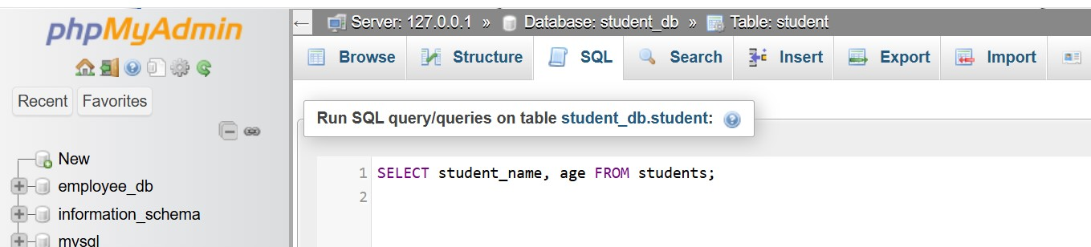

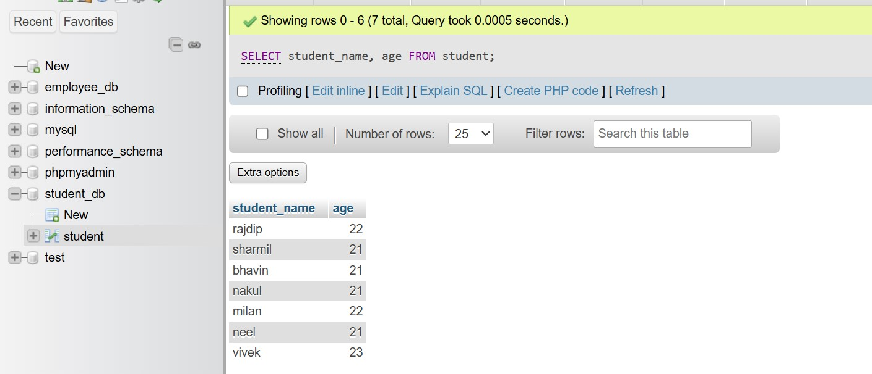

Lab 2: Write SQL queries to retrieve all students whose age is greater than 10.

Ans.

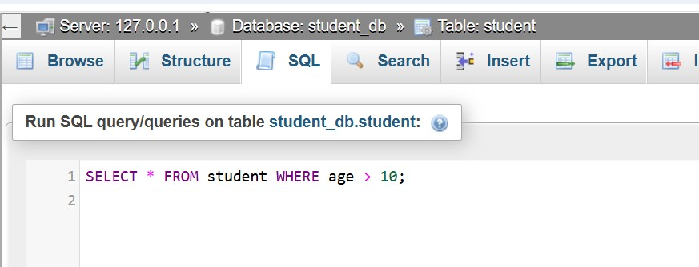

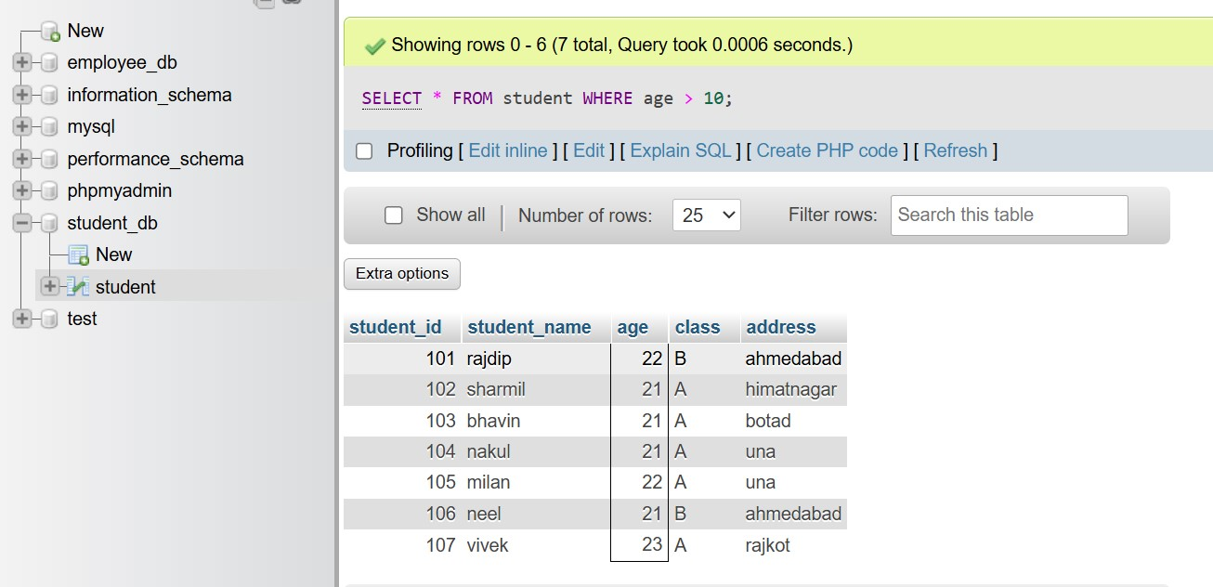

3. SQL Constraints

Theory Questions:

1. What are the constraints in SQL? List and explain the different types of constraints.

Ans. SQL constraints are used to specify rules for the data in a table.

Constraints can be column level or table level.

Column-level constraints apply to a column and table-level constraints apply to the whole table.

The following constraints are commonly used in SQL:

NOT NULL

Ensures that a column cannot have a NULL value

UNIQUE

Ensures that all values in a column are different

PRIMARY KEY

A combination of a NOT NULL and UNIQUE. Uniquely identifies each row in a table.

FOREIGN KEY

Prevents actions that would destroy links between tables

CHECK

Ensures that the values in a column satisfy a specific condition

DEFAULT

Sets a default value for a column if no value is specified

CREATE INDEX

Used to create and retrieve data from the database very quickly

2. How do PRIMARY KEY and FOREIGN KEY constraints differ?

Ans.

|  |  |  |
| --- | --- | --- |
| Feature | PRIMARY KEY | FOREIGN KEY |
| Purpose | Uniquely identifies each record in a table. | Establishes a relationship between two tables. |
| Uniqueness | Must be unique for each row. | Can have duplicate values in the referencing table. |
| NULL Values | Cannot be NULL. | Can contain NULL values. |
| Number Allowed | Only one per table. | Multiple foreign keys can exist in a table. |
| Reference | Defined in the same table. | References a PRIMARY KEY in another table. |
| Example | id in the employee's table uniquely identifies employees. | employee_id in the orders table links to the id in employees. |

3. What is the role of NOT NULL and UNIQUE constraints?

Ans.

SQL NOT NULL Constraint:

By default, a column can hold NULL values.

The NOT NULL constraint enforces a column to NOT accept NULL values.

CREATE TABLE Persons

(

ID int NOT NULL,

LastName varchar(255) NOT NULL,

FirstName varchar(255) NOT NULL,

Age int

);

SQL UNIQUE Constraint:

The UNIQUE constraint ensures that all values in a column are different.

Both the UNIQUE and PRIMARY KEY constraints provide a guarantee for uniqueness for a column or set of columns.

CREATE TABLE Persons

(

ID int NOT NULL UNIQUE,

LastName varchar(255) NOT NULL,

FirstName varchar(255),

Age int

);

LAB EXERCISES:

Lab 1: Create a table of teachers with the following columns: teacher_id (Primary Key), teacher_name (NOT NULL), subject (NOT NULL), and email (UNIQUE).

Ans.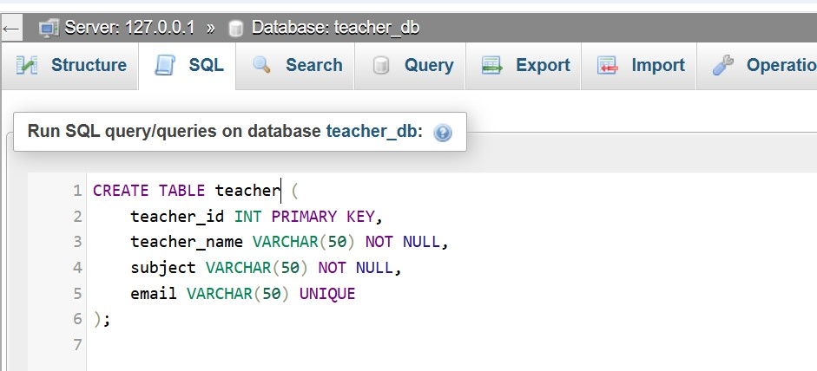

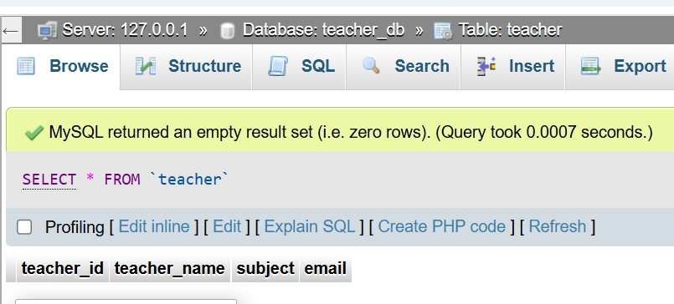

Lab 2: Implement a FOREIGN KEY constraint to relate the teacher_id from the teacher's table with the student's table.

Ans.

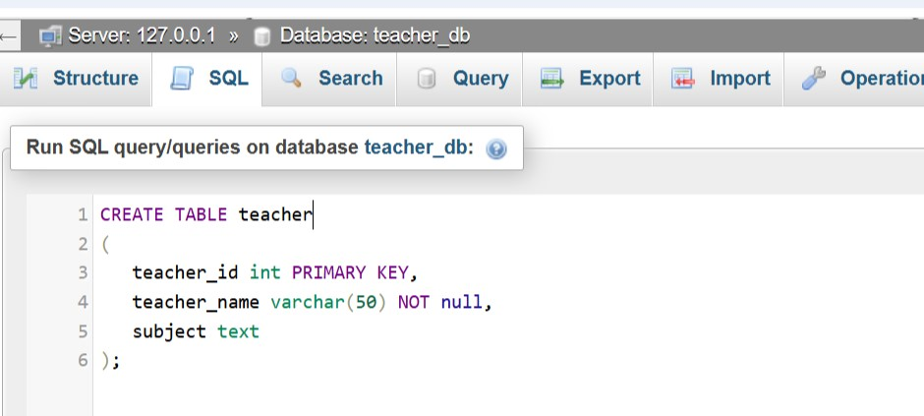

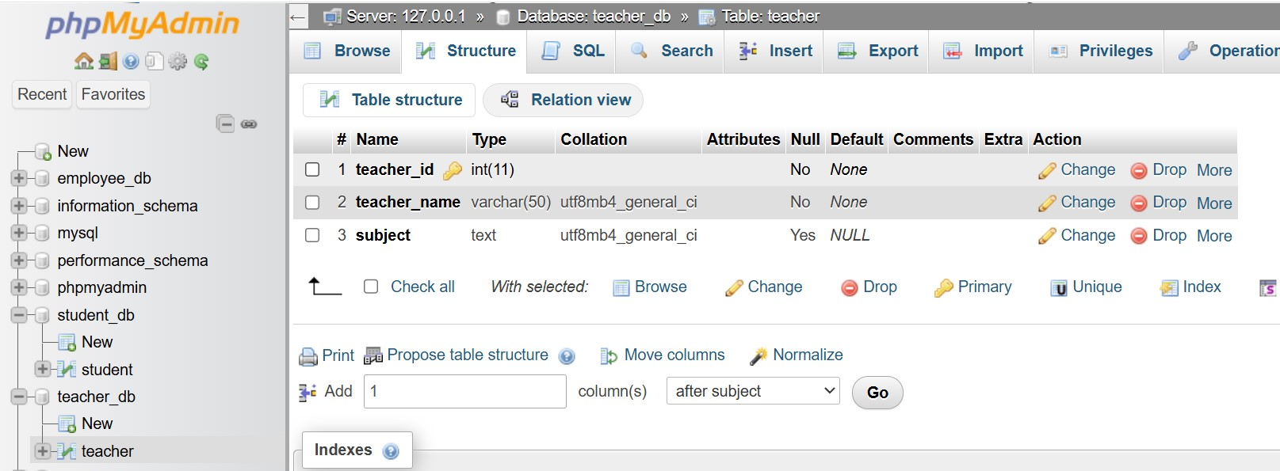

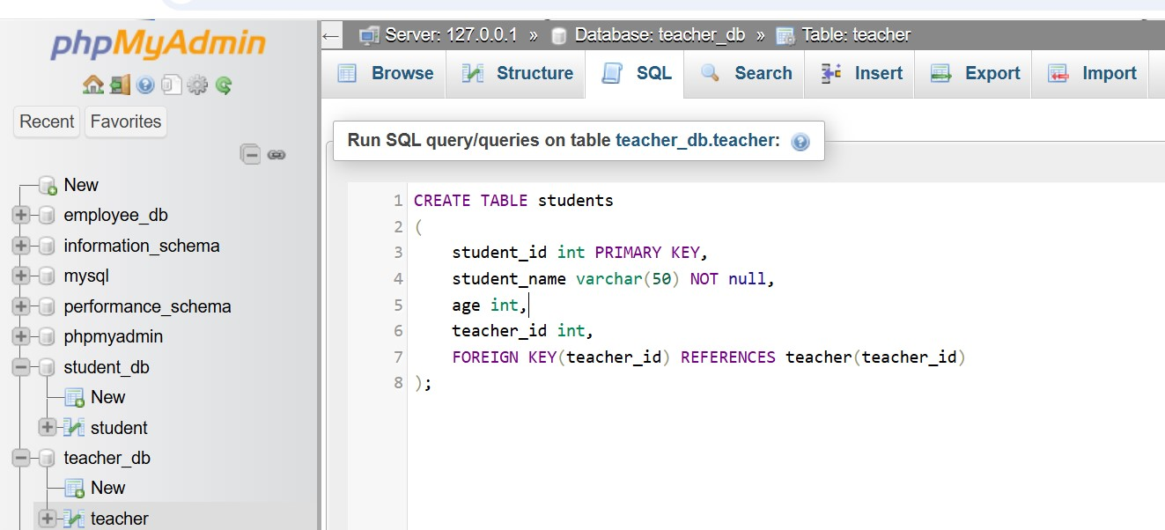

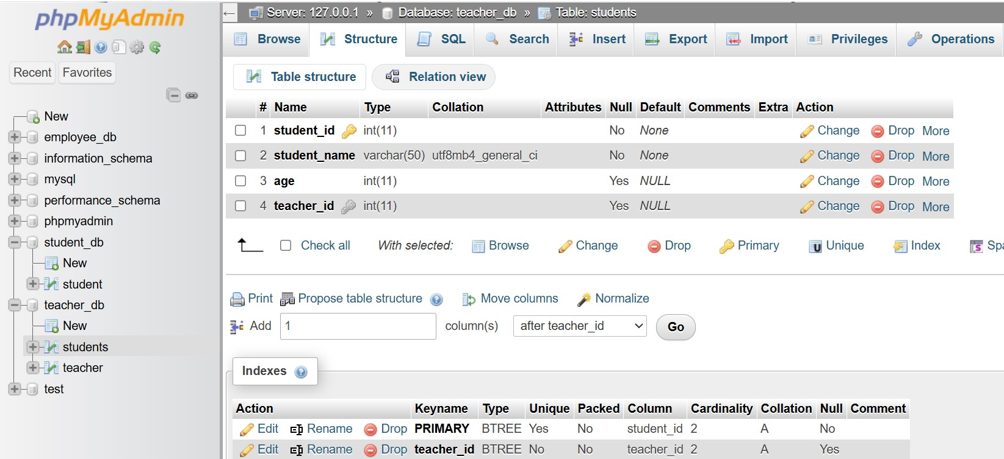

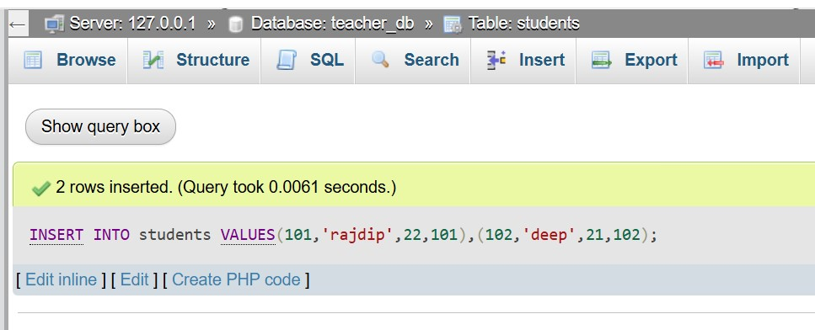

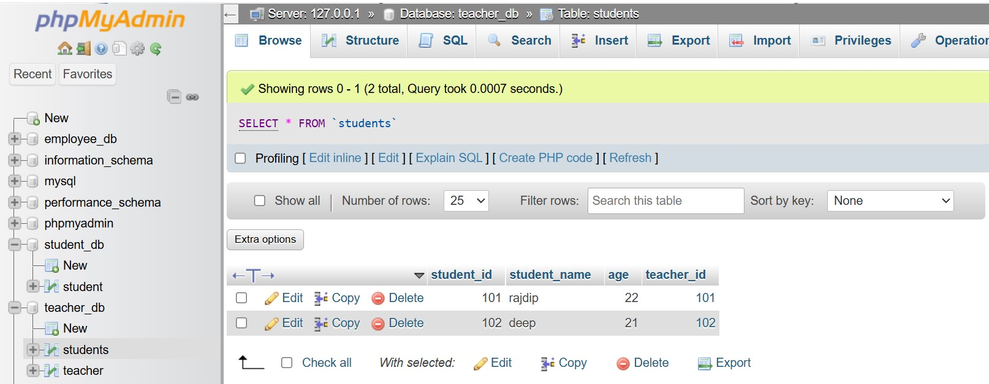

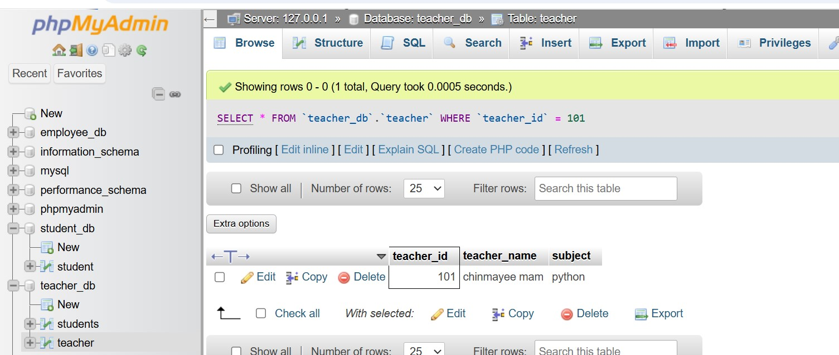

4. Main SQL Commands and Sub-commands (DDL)

Theory Questions:

1. Define the SQL Data Definition Language (DDL).

Ans.

1. Data Definition (DDL - Data Definition Language):

Creating, modifying, and deleting database structures such as tables, indexes, and schemas.

Commands: CREATE, TRUNCATE, DROP.

SQL CREATE TABLE Statement:

CREATE TABLE Employee (Emp_No int, Emp_Name varchar(50), Salary int);

The SQL DROP TABLE Statement:

DROP TABLE TestEmployee;

SQL TRUNCATE TABLE:

TRUNCATE TABLE TestEmployee;

To delete the data inside a table, but not the table itself.

2. Explain the CREATE command and its syntax.

Ans.

SQL CREATE Command:

The CREATE command in SQL is used to create new database objects such as databases, tables, indexes, views, and schemas.

It is part of the Data Definition Language (DDL) and helps define the structure of these objects.

The CREATE command defines the structure of database objects.

1. Create a Database:

CREATE DATABASE company_db;

Syntax of CREATE TABLE:

CREATE TABLE table_name (

column1 datatype constraints,

column2 datatype constraints,

...

);

3. What is the purpose of specifying data types and constraints during table creation?

Ans.

1. Purpose of Data Types:

Data types define the kind of data a column can store, preventing invalid entries and optimizing storage.

Data types ensure correct and efficient storage of values.

Example:

CREATE TABLE employees (

id INT,

name VARCHAR(50),

salary INT

);

2. Purpose of Constraints:

Constraints enforce rules on the data stored in a table, ensuring its validity and integrity.

Example:

CREATE TABLE employees (

id INT PRIMARY KEY,

name VARCHAR(50) NOT NULL,

age INT CHECK (age >= 18),

email VARCHAR(100) UNIQUE,

department_id INT,

FOREIGN KEY (department_id) REFERENCES departments(id)

);

LAB EXERCISES:

Lab 1: Create a table of courses with columns: course_id, course_name, and course_credits. Set the course_id as the primary key.

Ans.

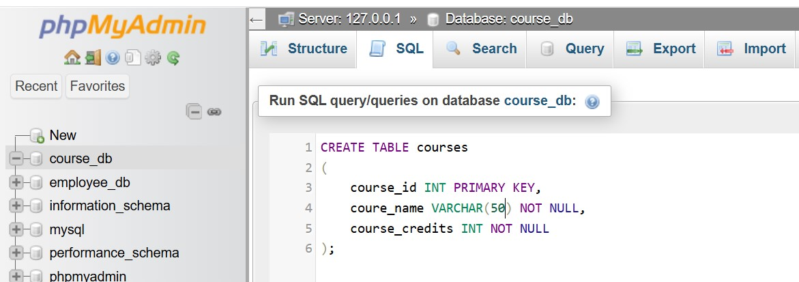

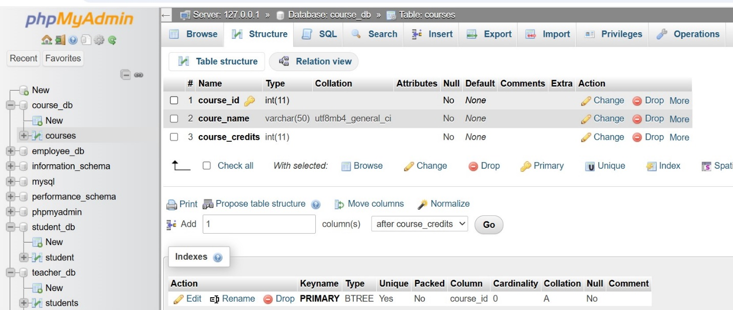

Lab 2: Use the CREATE command to create a database university_db.

Ans.

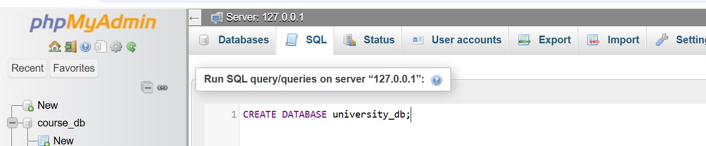

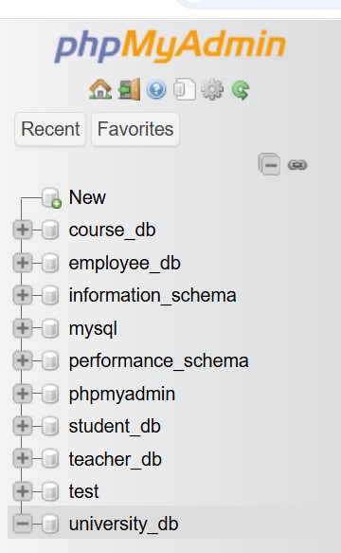

5. ALTER Command

Theory Questions:

1. What is the use of the ALTER command in SQL?

Ans.

It is part of the Data Definition Language (DDL).

allows adding, modifying, or deleting table columns and constraints.

ALTER allows modifying table structure without losing data.

It can add, modify, rename, or delete columns and constraints.

Helps adapt the database to changing requirements efficiently.

1. Add a New Column to a Table:

ALTER TABLE employees ADD COLUMN salary int;

1. Drop (Delete) a Column from a Table:

ALTER TABLE employees DROP COLUMN age;

1. Rename a Table:

ALTER TABLE employees RENAME TO staff;

2. How can you add, modify, and drop columns from a table using ALTER?

Ans.

The ALTER TABLE command allows you to add, modify, and drop columns in an existing table without losing data.

1. Add a Column to a Table:

You can add a new column to an existing table using the ADD clause.

Example:

ALTER TABLE employees ADD COLUMN salary float;

2. Modify an Existing Column:

You can change the data type, size, or constraints of an existing column using the MODIFY or ALTER COLUMN clause.

Example:

ALTER TABLE employees MODIFY COLUMN salary float;

3. Drop (Delete) a Column from a Table:

To remove a column from a table, use the DROP COLUMN clause.

Example:

ALTER TABLE employees DROP COLUMN age;

LAB EXERCISES:

Lab 1: Modify the courses table by adding a column course_duration using the ALTER command.

Ans.

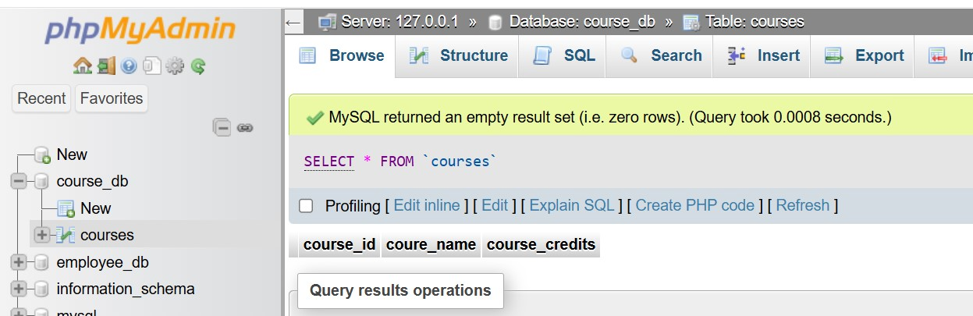

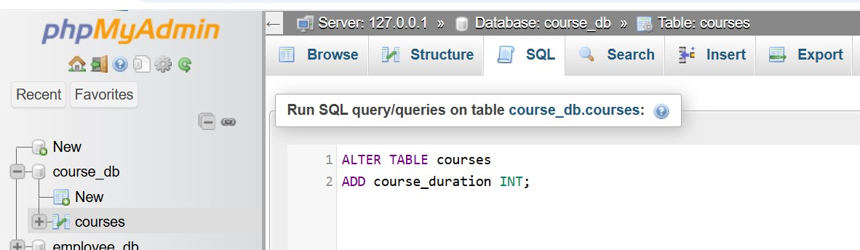

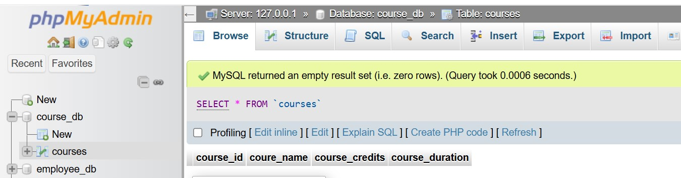

Lab 2: Drop the course_credits column from the courses table.

Ans.

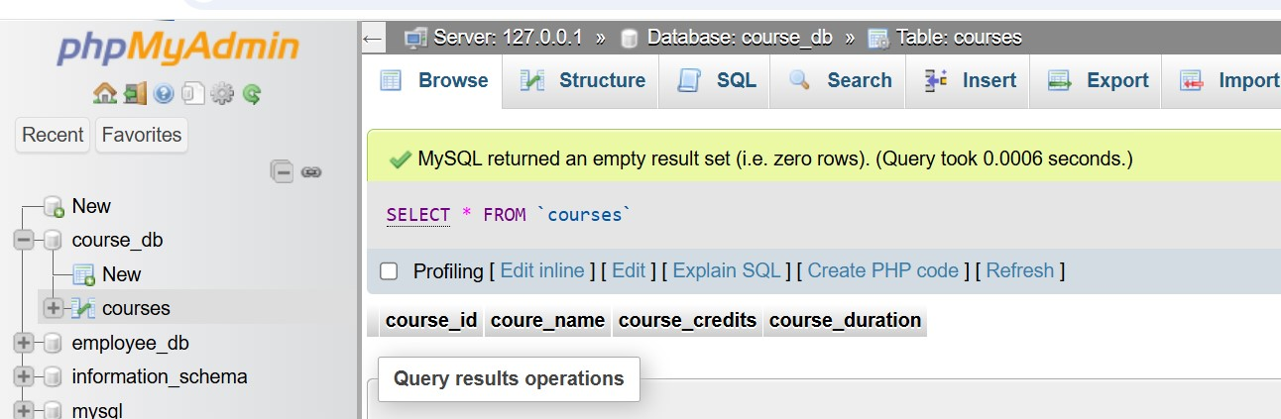

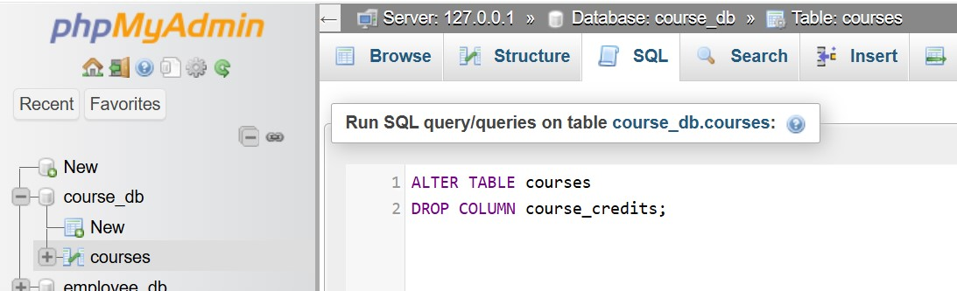

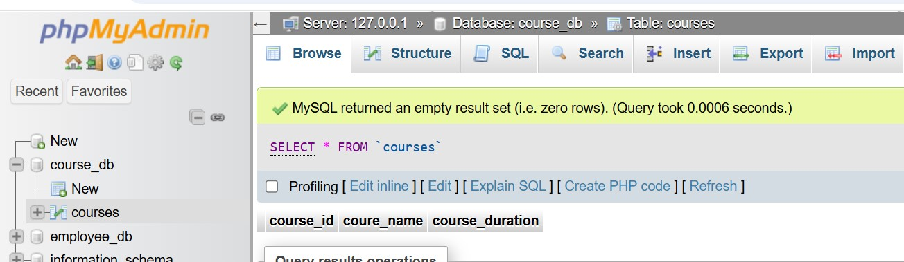

6. DROP Command

Theory Questions:

1. What is the function of the DROP command in SQL?

Ans.

The DROP command permanently deletes database objects.

It cannot be undone, so use it carefully.

It can remove tables, databases, columns, indexes, and views.

1. Drop a Table (Delete a Table):

Example:

DROP TABLE employees;

2. Drop a Database (Delete an Entire Database):

Example:

DROP DATABASE company_db;

3. Drop a Column from a Table:

Example:

ALTER TABLE employees DROP COLUMN age;

2. What are the implications of dropping a table from a database?

Ans.

Dropping a table is permanent – use it cautiously.

Foreign key constraints and relationships may break.

Back up your data before executing the DROP TABLE.

1. Data Loss:

All records in the table are permanently deleted.

The data cannot be recovered unless a backup exists.

1. Loss of Table Structure:

The table definition (like columns, and data types) is removed.

You must recreate the table manually if needed later.

Example: Dropping a Table

DROP TABLE employees;

LAB EXERCISES:

Lab 1: Drop the teacher's table from the school_db database.

Ans.

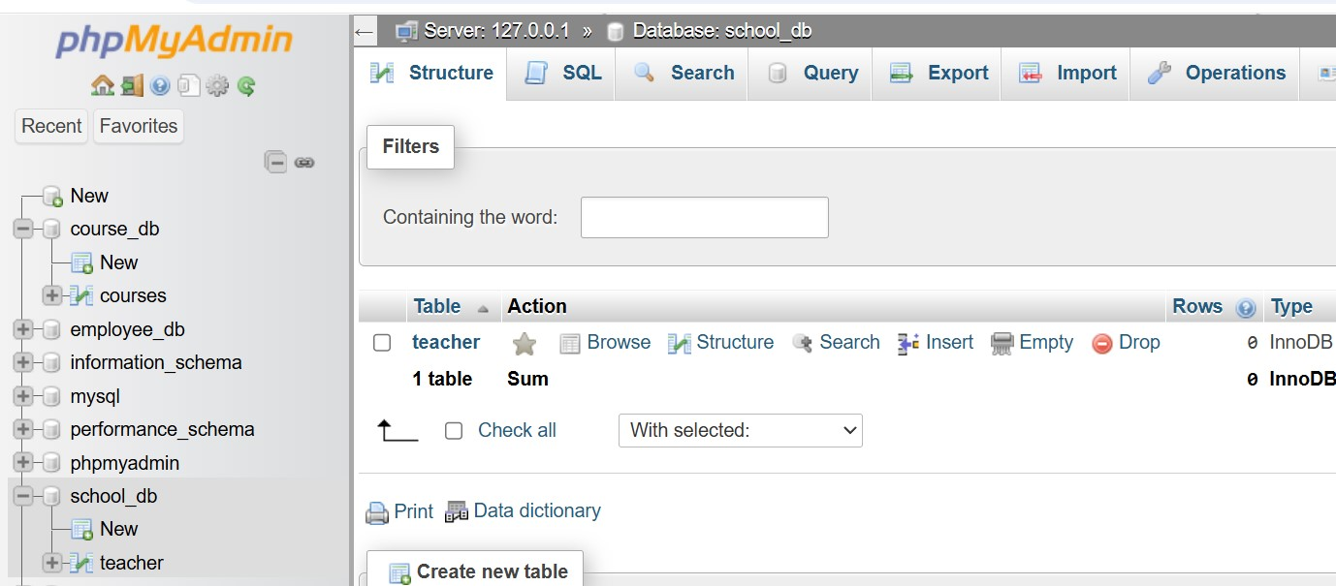

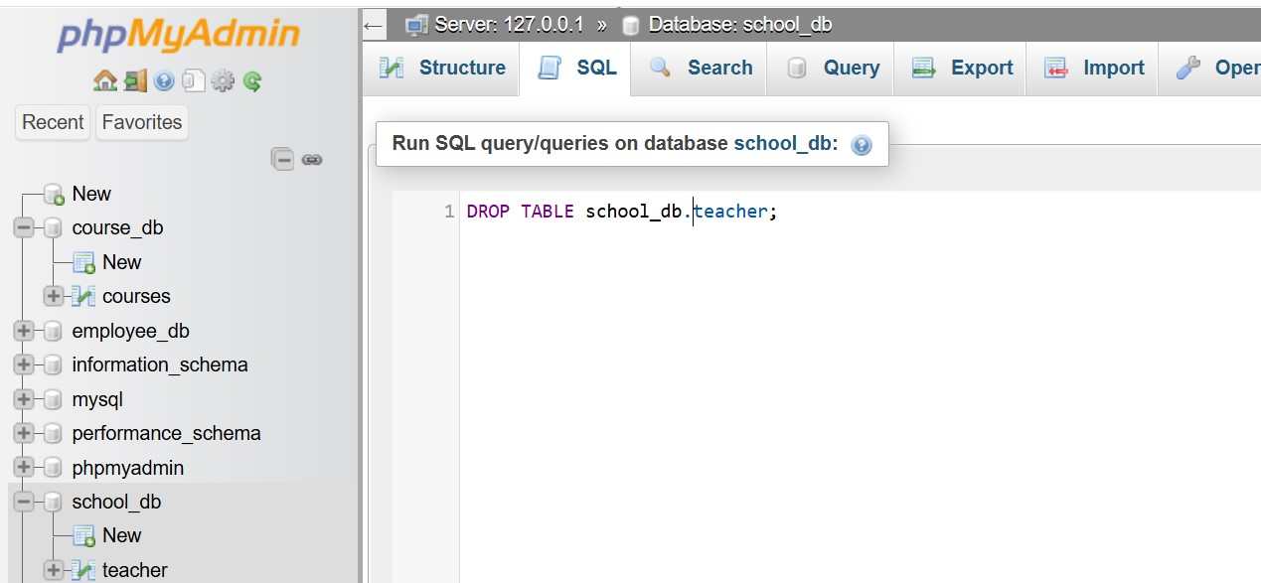

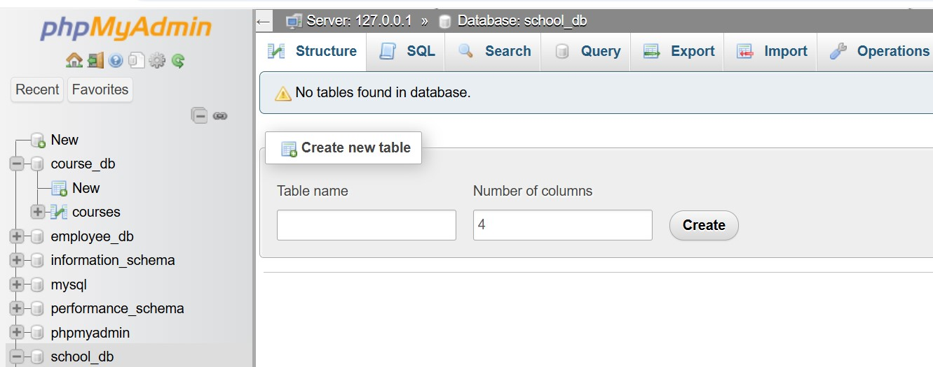

Lab 2: Drop the student's table from the school_db database and verify that the table has been removed.

Ans.

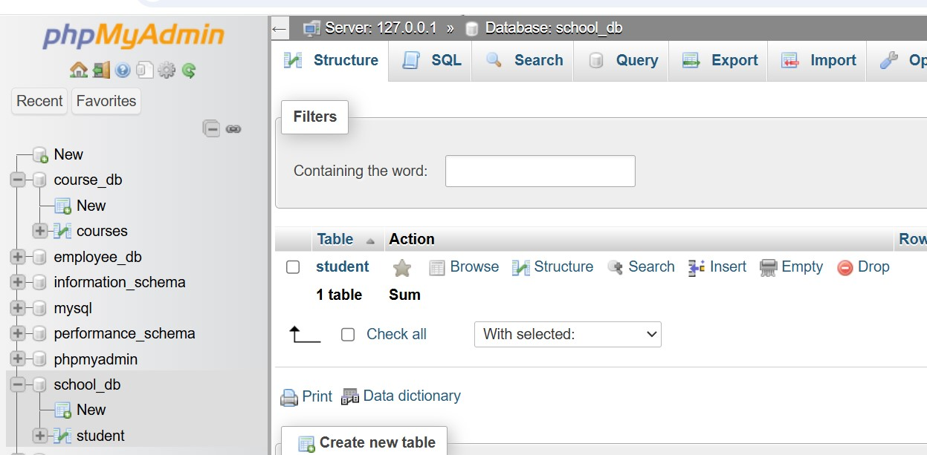

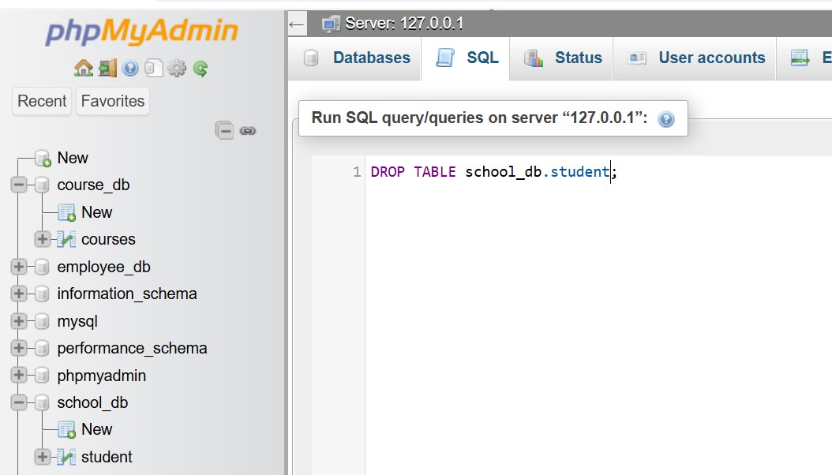

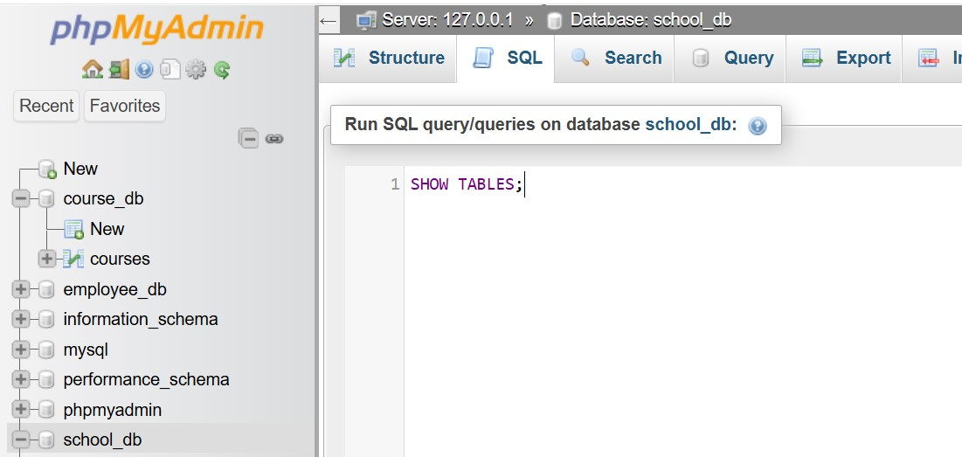

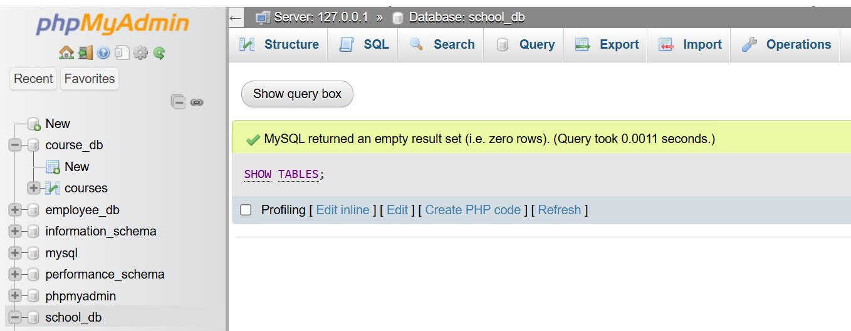

7. Data Manipulation Language (DML)

Theory Questions:

1. Define the INSERT, UPDATE, and DELETE commands in SQL.

Ans.

These commands are part of Data Manipulation Language (DML).

SQL is used to manage and modify data within database tables.

1. INSERT Command – Add New Records:

The INSERT command is used to add new rows to a table.

Example:

INSERT INTO employees (id, name, age, department)

VALUES (101, 'meet', 30, 'HR');

2. UPDATE Command – Modify Existing Records:

The UPDATE command modifies existing data in a table.

Example:

UPDATE employees

SET age = 32

WHERE id = 101;

3. DELETE Command – Remove Records:

The DELETE command is used to remove records from a table.

Example:

DELETE FROM employees WHERE id = 103;

2. What is the importance of the WHERE clause in UPDATE and DELETE operations?

Ans.

All rows in the table will be modified or deleted, leading to data loss or unintended changes.

1. Importance in UPDATE Statements:

The WHERE clause ensures that only specific records are updated.

Example:

UPDATE employees

SET age = 35

WHERE id = 101;

Without WHERE, every row is updated!

Example:

UPDATE employees

SET age = 35;

2. Importance in DELETE Statements:

The WHERE clause prevents accidental deletion of all records in the table.

Example:

DELETE FROM employees

WHERE id = 103;

Without WHERE, every record is deleted!

Example:

DELETE FROM employees;

LAB EXERCISES:

Lab 1: Insert three records into the courses table using the INSERT command.

Ans.

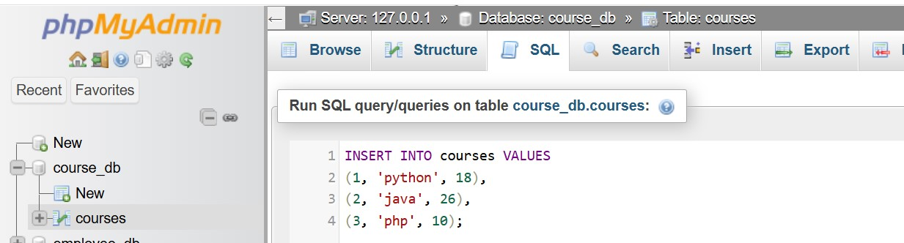

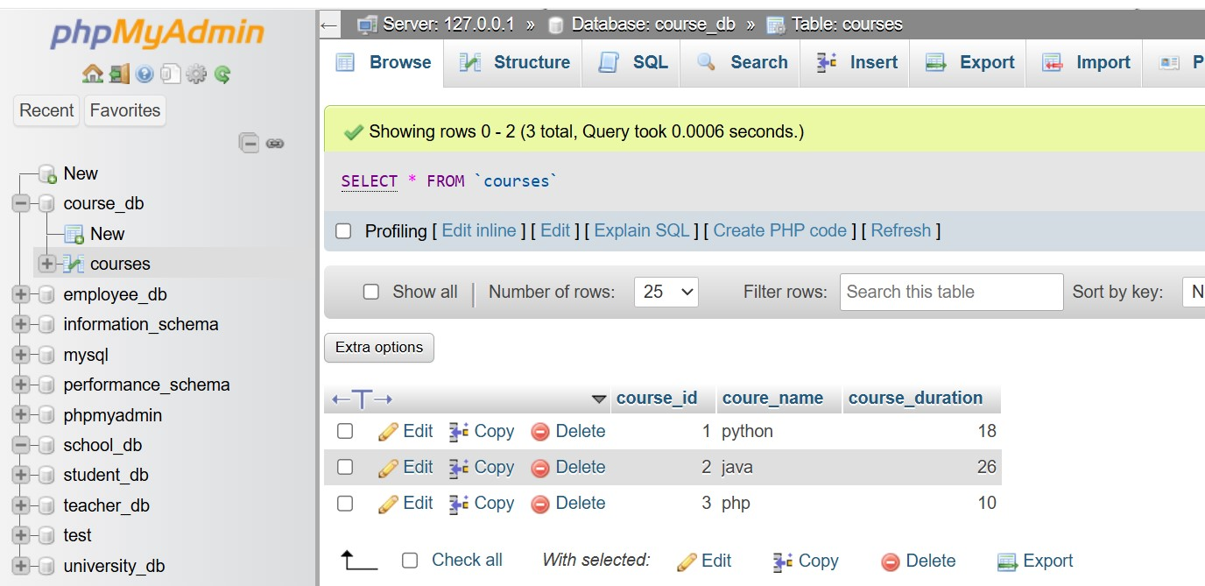

Lab 2: Update the course duration of a specific course using the UPDATE command.

Ans.



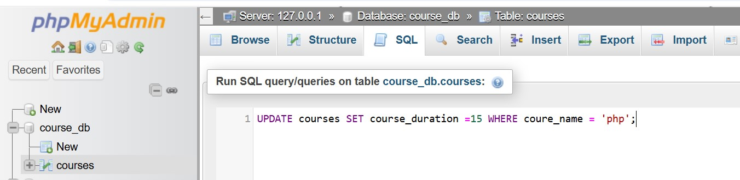

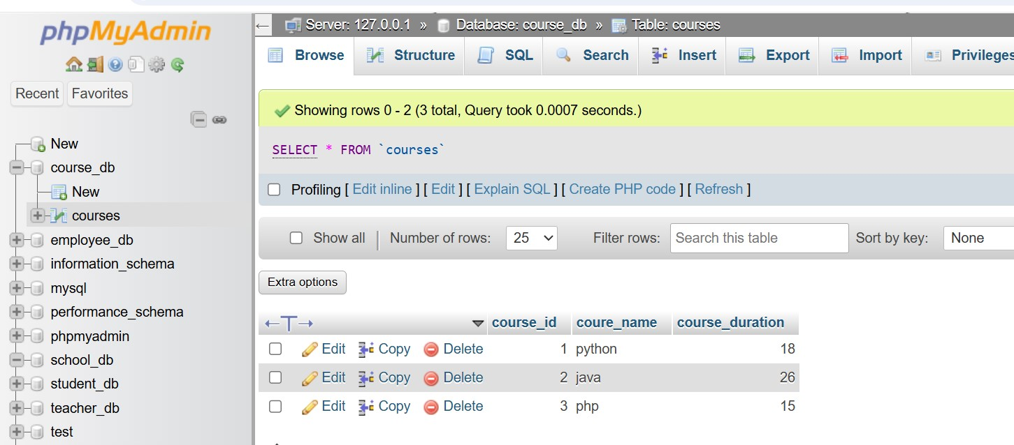

Lab 3: Delete a course with a specific course_id from the courses table using the DELETE command.

Ans.



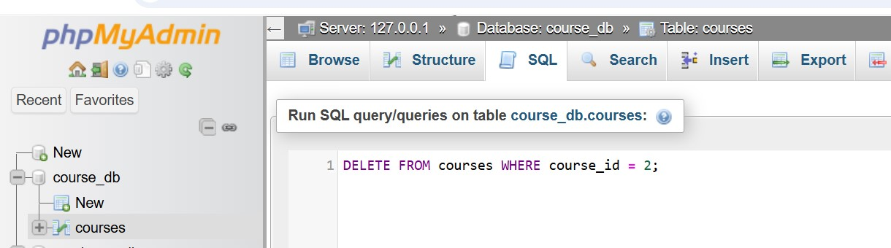

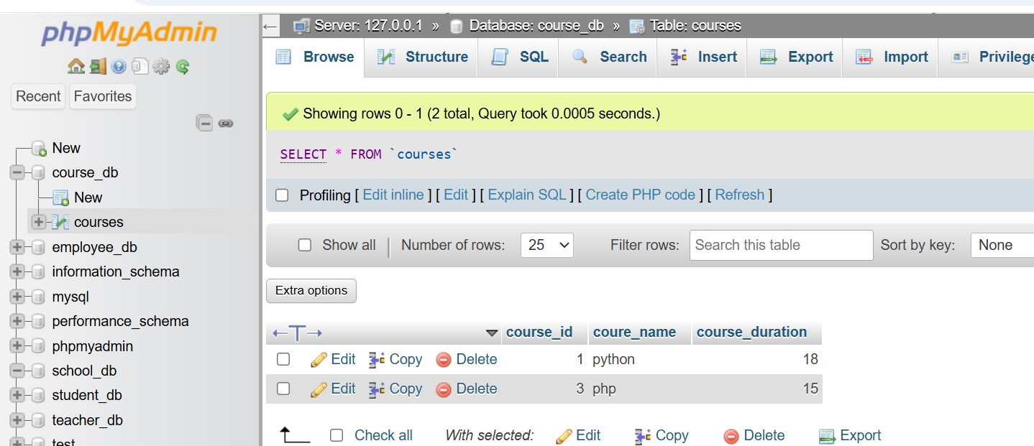

8. Data Query Language (DQL)

Theory Questions:

1. What is the SELECT statement, and how is it used to query data?

Ans.

The SELECT statement is one of the most important SQL commands.

It is used to query data from a table and retrieve specific records based on conditions.

1. Basic Syntax of SELECT:

SELECT column1, column2, ... FROM table_name;

Example:

SELECT name, age FROM employees;

2. Using WHERE to Filter Data:

The WHERE clause helps retrieve specific records based on a condition.

Example:

SELECT name, department FROM employees

WHERE department = 'IT';

3. Sorting Results Using ORDER BY:

The ORDER BY clause sorts query results in ascending (ASC) or descending (DESC) order.

Example:

SELECT name, age FROM employees

ORDER BY age DESC;

4. Using GROUP BY for Aggregations:

The GROUP BY clause groups results based on a column and HAVING filters aggregated results.

Example:

SELECT department, COUNT(*) AS total_employees

FROM employees

GROUP BY department;

2. Explain the use of the ORDER BY and WHERE clauses in SQL queries.

Ans.

1. WHERE Clause – Filtering Data:

The WHERE clause is used to filter records by specifying conditions. It helps retrieve only the relevant rows from a table.

Syntax:

SELECT column1, column2

FROM table_name

WHERE condition;

Example:

SELECT name, department

FROM employees

WHERE department = 'IT';

2. ORDER BY Clause – Sorting Data:

The ORDER BY clause is used to sort query results in ascending (ASC) or descending (DESC) order.

Syntax:

SELECT column1, column2

FROM table_name

ORDER BY column_name [ASC | DESC];

Example:

SELECT name, age FROM employees

ORDER BY age ASC;

LAB EXERCISES:

Lab 1: Retrieve all courses from the courses table using the SELECT statement.

Ans.

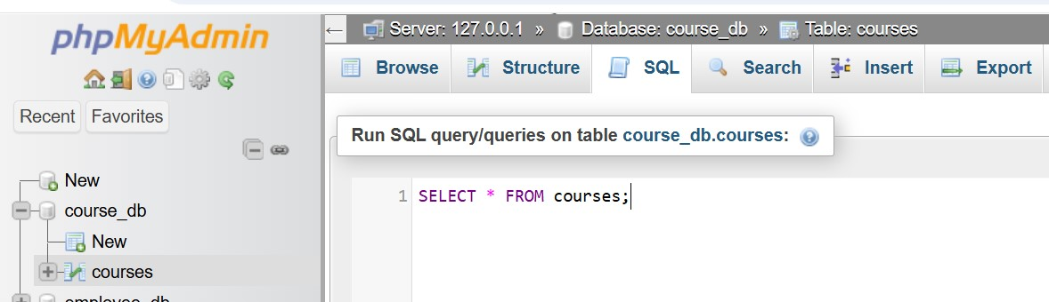

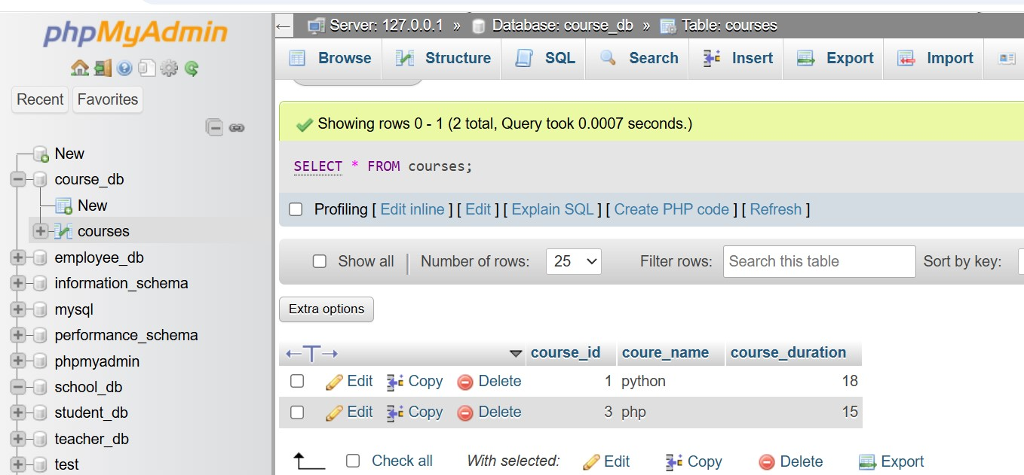

Lab 2: Sort the courses based on course_duration in descending order using ORDER BY.

Ans.

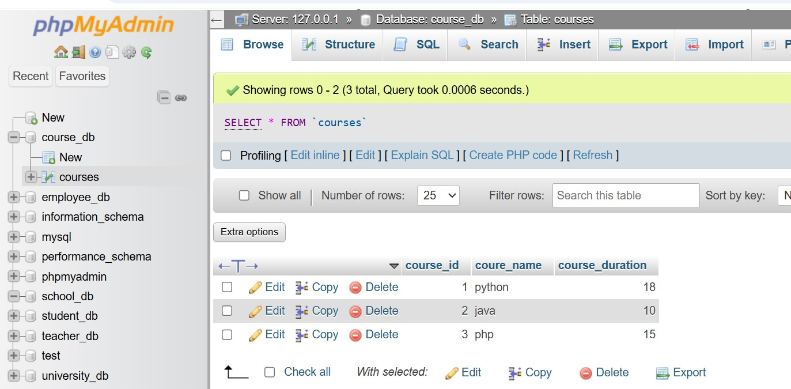

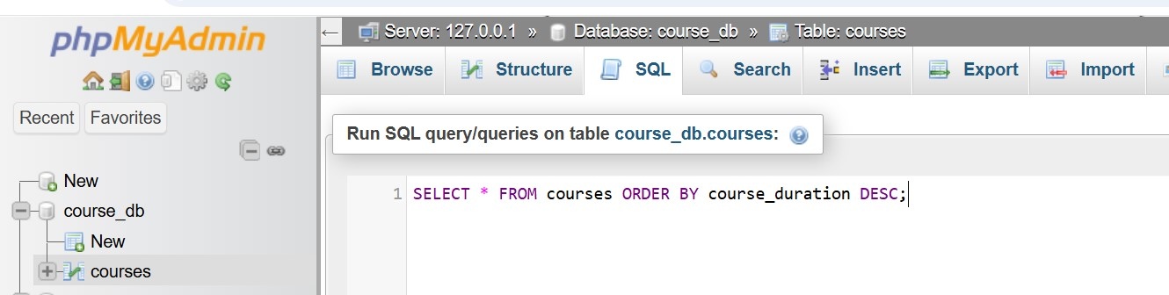

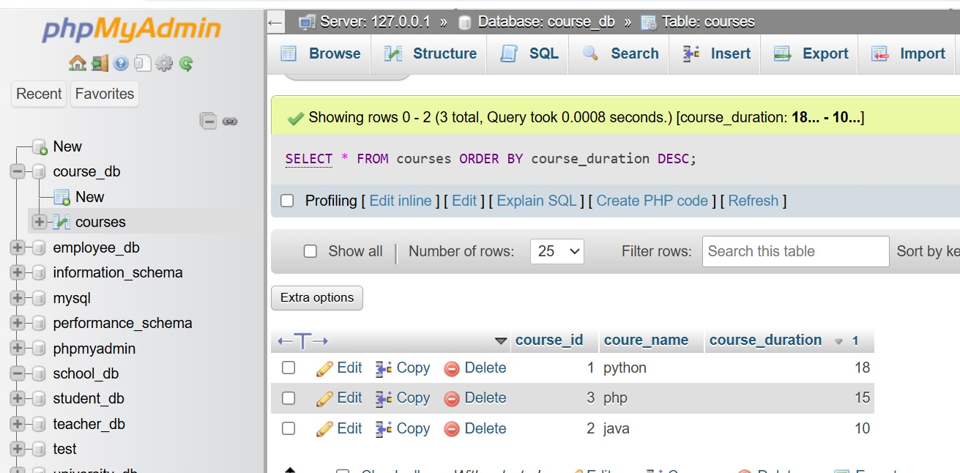

Lab 3: Limit the results of the SELECT query to show only the top two courses using LIMIT.

Ans.



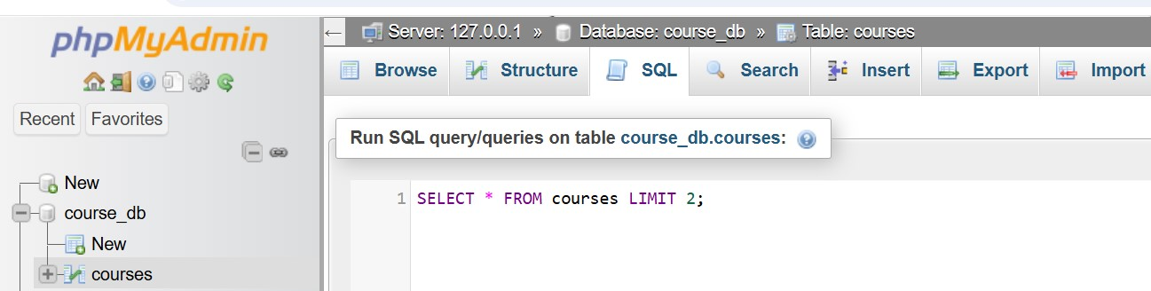

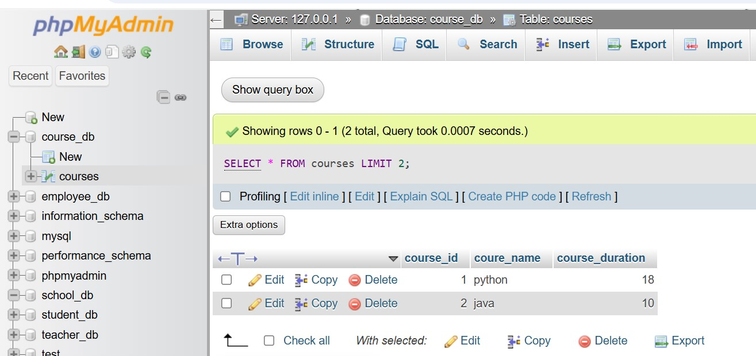

9. Data Control Language (DCL)

Theory Questions:

1. What is the purpose of GRANT and REVOKE in SQL?

Ans.

GRANT is used to give users access to database objects.

REVOKE is used to remove permissions from users.

Database administrators use these commands to control security and protect data integrity.

|  |  |  |
| --- | --- | --- |
| Command | Purpose | Example |
| GRANT | Assigns privileges to a user. | GRANT SELECT ON employees to Raj; |
| REVOKE | Removes privileges from a user. | REVOKE SELECT ON employees FROM Raj; |
| Effect | Increases user access. | Restricts user access. |

2. How do you manage privileges using these commands?

Ans.

Use roles instead of assigning privileges to each user manually.  
Grant only necessary permissions to protect data.  
Regularly audit privileges to maintain security.

|  |  |  |
| --- | --- | --- |
| Command | Purpose | Example |
| GRANT | Assign privileges to a user or role. | GRANT SELECT ON employees to Raj; |
| REVOKE | Remove privileges from a user or role. | REVOKE UPDATE ON employees FROM Raj; |
| WITH GRANT OPTION | Allows a user to grant the same privileges to others. | GRANT SELECT ON employees to Raj WITH GRANT OPTION; |
| Roles | Group privileges for easier management. | GRANT SELECT TO database_db; |

LAB EXERCISES:

Lab 1: Create two new users user1 and user2 and grant user1 permission to SELECT from the courses table.

Ans.

CREATE USER 'user1'@'localhost' IDENTIFIED BY 'password1';

CREATE USER 'user2'@'localhost' IDENTIFIED BY 'password2';

GRANT SELECT ON school.courses TO 'user1'@'localhost';

Lab 2: Revoke the INSERT permission from user1 and give it to user2.

Ans.

REVOKE INSERT ON your_database.courses FROM 'user1'@'localhost';

GRANT INSERT ON your_database.courses TO 'user2'@'localhost';

10. Transaction Control Language (TCL)

Theory Questions:

1. What is the purpose of the COMMIT and ROLLBACK commands in SQL?

Ans. Transactions improve database consistency and integrity.

1. COMMIT – Saving Changes Permanently:

The COMMIT command saves all the changes made during a transaction permanently in the database.

COMMIT saves changes permanently.

Syntax:

COMMIT;

Example:

BEGIN TRANSACTION;

INSERT INTO employees (id, name, department) VALUES (101, 'raj', 'HR');

COMMIT;

2. ROLLBACK – Undoing Changes:

The ROLLBACK command undoes all changes made during the current transaction if they haven't been committed.

ROLLBACK undoes changes made in a transaction.

Syntax:

ROLLBACK;

Example:

BEGIN TRANSACTION;

INSERT INTO employees (id, name, department) VALUES (102, 'Bob', 'Finance');

ROLLBACK;

2. Explain how transactions are managed in SQL databases.

Ans.

A transaction in SQL is a sequence of operations performed as a single unit of work.

transactions Table:

|  |  |
| --- | --- |
| command | purpose |
| BEGIN TRANSACTION | Starts a new transaction |
| COMMIT | Saves all changes permanently |
| ROLLBACK | Undoes all changes in the transaction |
| SAVEPOINT | Creates a checkpoint to roll back part of a transaction |
| ROLLBACK TO SAVEPOINT | Rolls back to a specific checkpoint |
| SET TRANSACTION ISOLATION LEVEL | Controls isolation level for transactions |

LAB EXERCISES:

Lab 1: Insert a few rows into the courses table and use COMMIT to save the changes.

Ans.

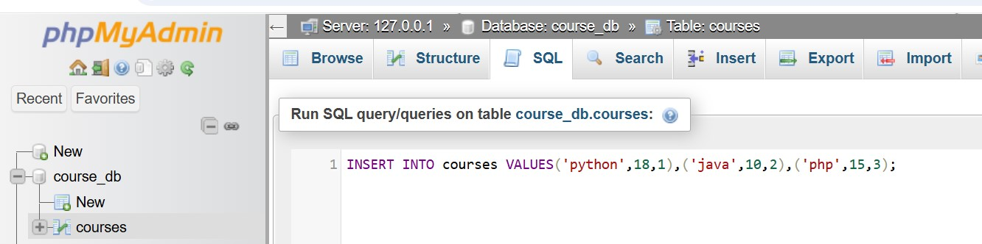

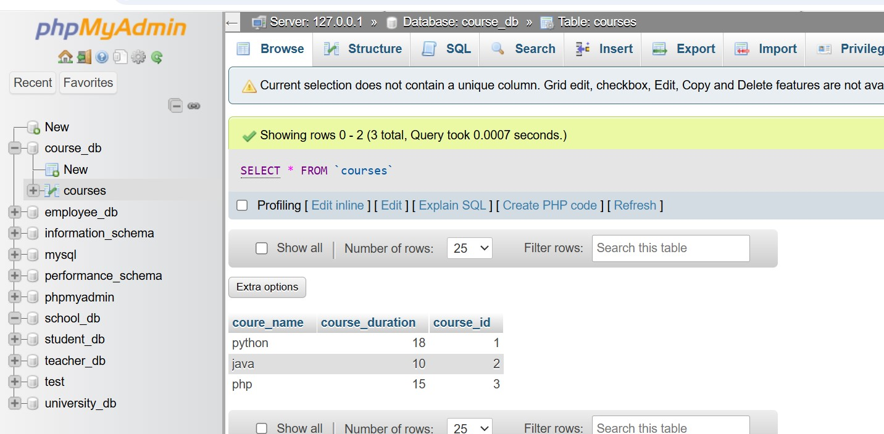

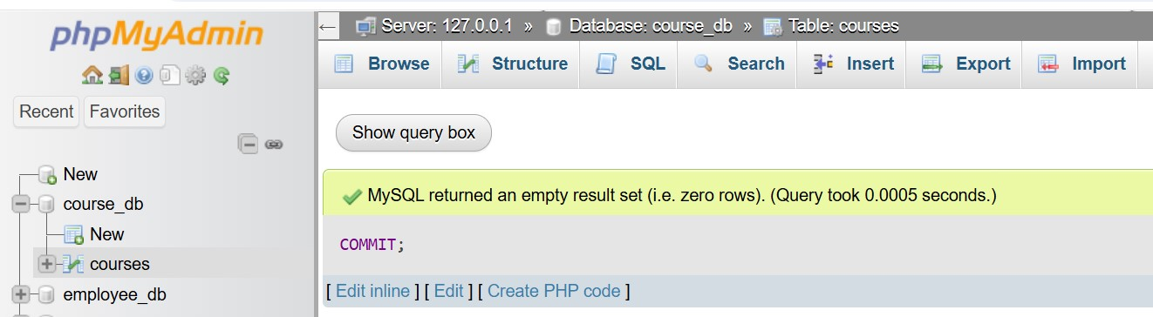

Lab 2: Insert additional rows, then use ROLLBACK to undo the last insert operation.

Ans.

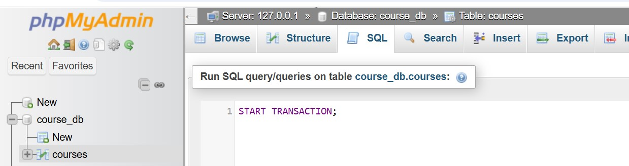

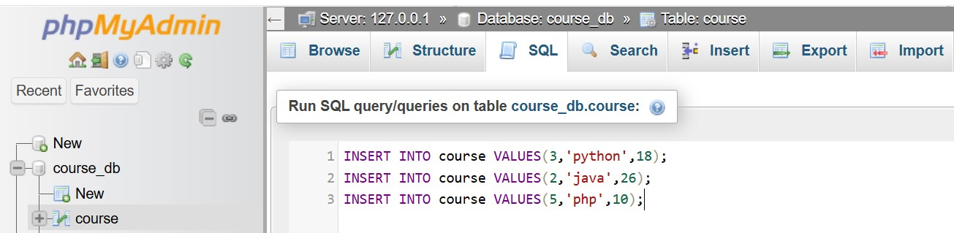

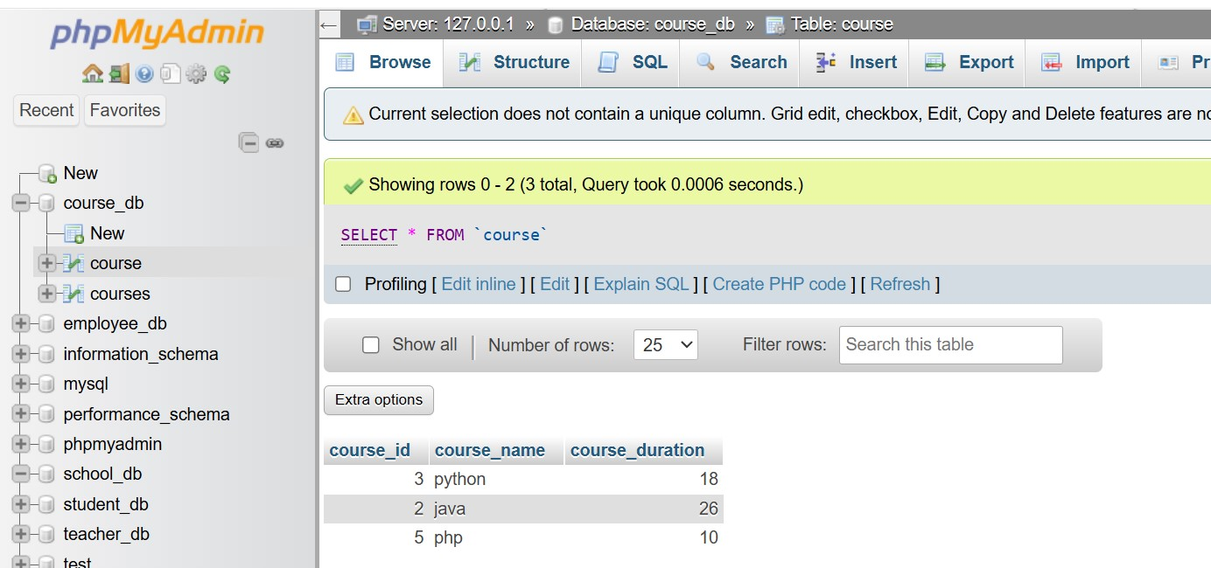

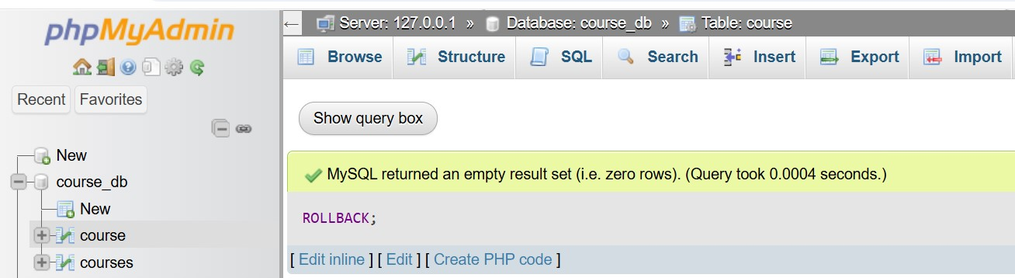

Lab 3: Create a SAVEPOINT before updating the courses table, and use it to roll back specific changes.

Ans.

START TRANSACTION; SAVEPOINT before_changes;

INSERT INTO courses VALUES(3, 'PHP', 6), (4, '.NET', 7);

UPDATE courses SET course_duration = 10 WHERE course_id = 5;

ROLLBACK TO SAVEPOINT before_changes;

11. SQL Joins

Theory Questions:

1. Explain the concept of JOIN in SQL. What is the difference between INNER JOIN, LEFT JOIN, RIGHT JOIN, and FULL OUTER JOIN?

Ans.

A JOIN clause is used to combine rows from two or more tables, based on a related column between them.

The join keyword merges two or more tables and creates a temporary image of the merged table.

(INNER) JOIN:

Returns records that have matching values in both tables.

LEFT (OUTER) JOIN:

Returns all records from the left table, and the matched records from the right table.

RIGHT (OUTER) JOIN:

Returns all records from the right table, and the matched records from the left table.

FULL (OUTER) JOIN:

Returns all records when there is a match in either the left or right table.

JOIN Differences:

|  |  |  |
| --- | --- | --- |
| JOIN type | Includes Unmatched Rows? | Matching Rows |
| INNER JOIN | No | Yes |
| LEFT JOIN | Left table only | Yes |
| RIGHT JOIN | Right table only | Yes |
| FULL OUTER JOIN | Both tables | yes |

2. How are joins used to combine data from multiple tables?

Ans.

JOIN is used to combine data from multiple tables based on a common column. This helps retrieve meaningful, structured data by linking related tables.

1. Why Use JOIN?

In relational databases, data is often stored in separate tables to avoid redundancy.

Example:

We have two tables:

orders (Order details)

customers (Customer details)

orders (Order details):

|  |  |  |
| --- | --- | --- |
| Order_id | Customer_id | Totoal_amount |
| 1 | 101 | 500 |
| 2 | 102 | 400 |
| 3 | 103 | 300 |

Customers (Customer details):

|  |  |  |
| --- | --- | --- |
| Customer_id | Name | City |
| 101 | Rajdip | Ahmedabad |
| 102 | Raj | Rajkot |
| 104 | deep | gandhinagar |

(INNER) JOIN:

Returns records that have matching values in both tables.

LEFT (OUTER) JOIN:

Returns all records from the left table, and the matched records from the right table.

RIGHT (OUTER) JOIN:

Returns all records from the right table, and the matched records from the left table.

FULL (OUTER) JOIN:

Returns all records when there is a match in either the left or right table.

LAB EXERCISES:

Lab 1: Create two tables: departments and employees. Perform an INNER JOIN to display employees along with their respective departments.

Ans.

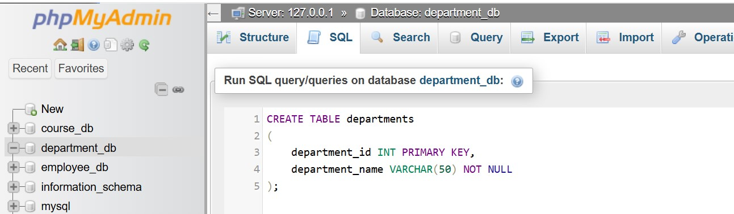

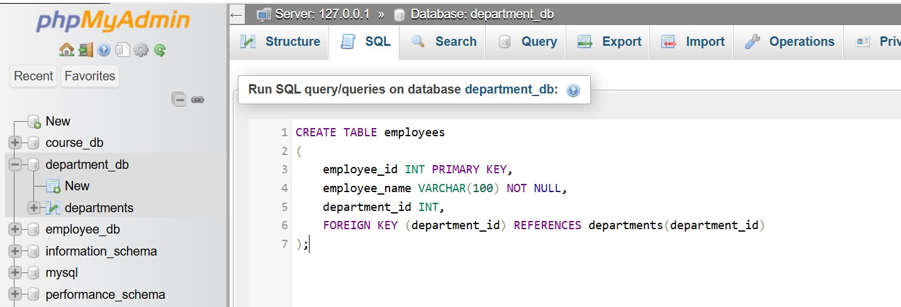

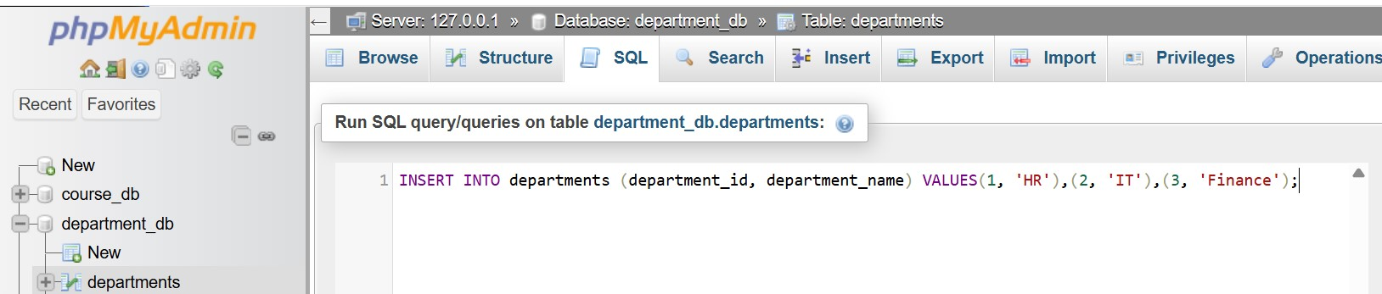

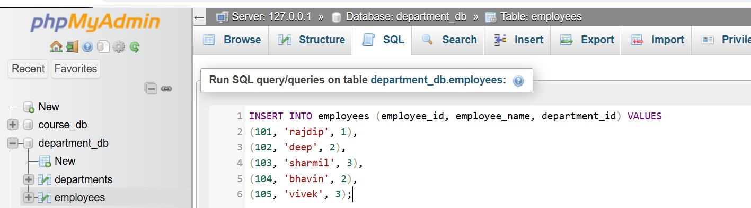

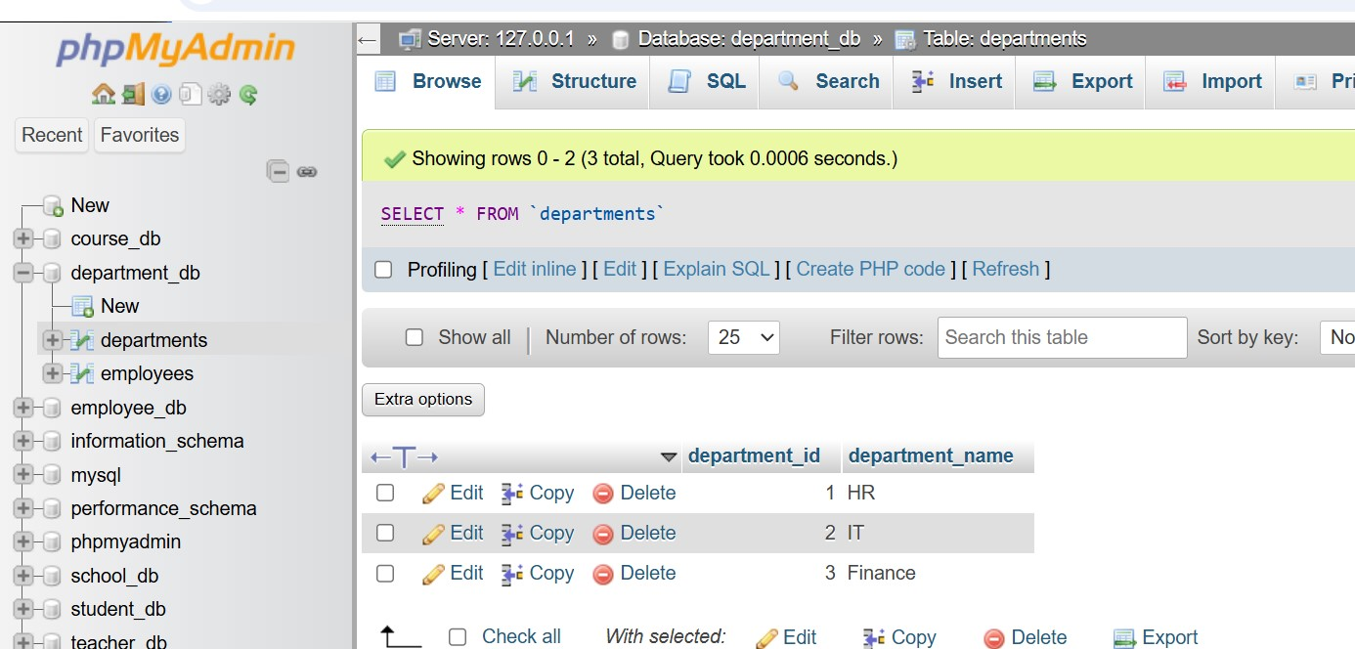

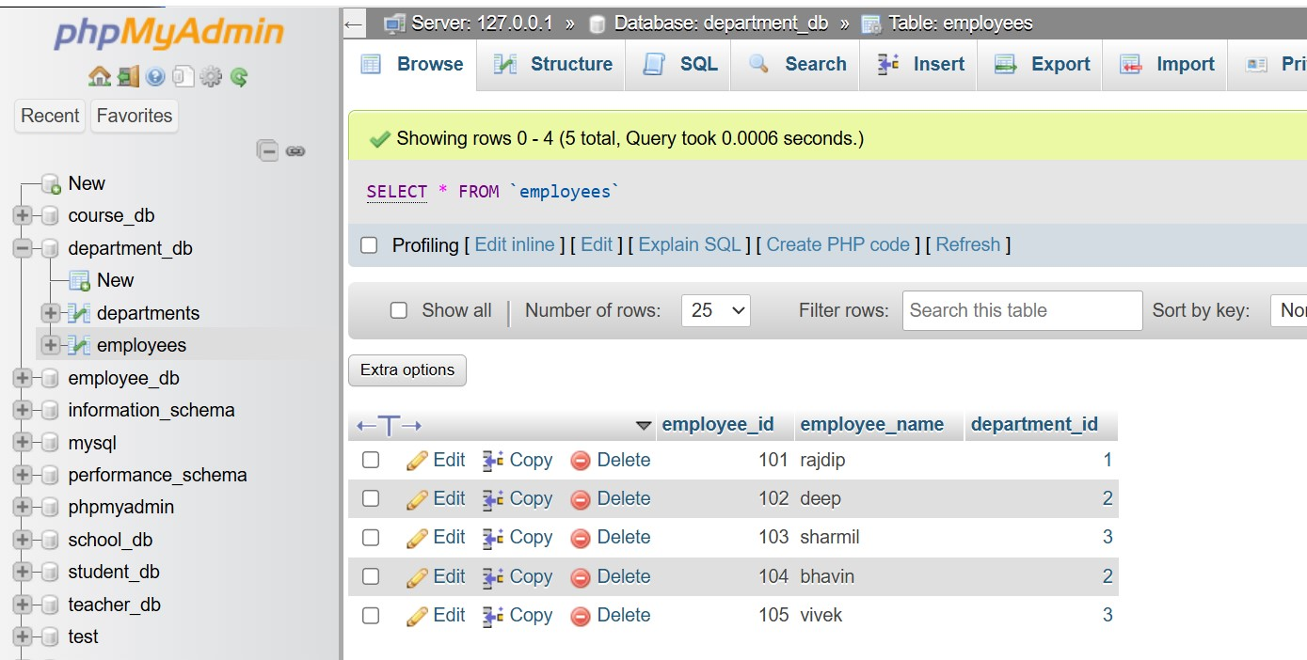

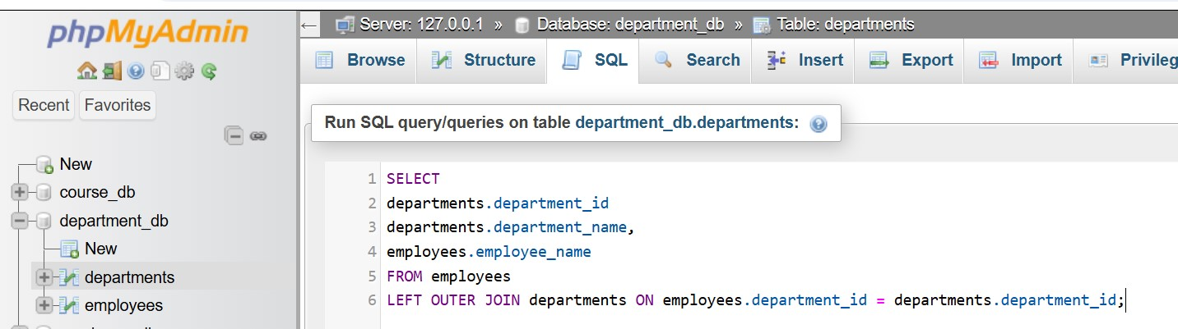

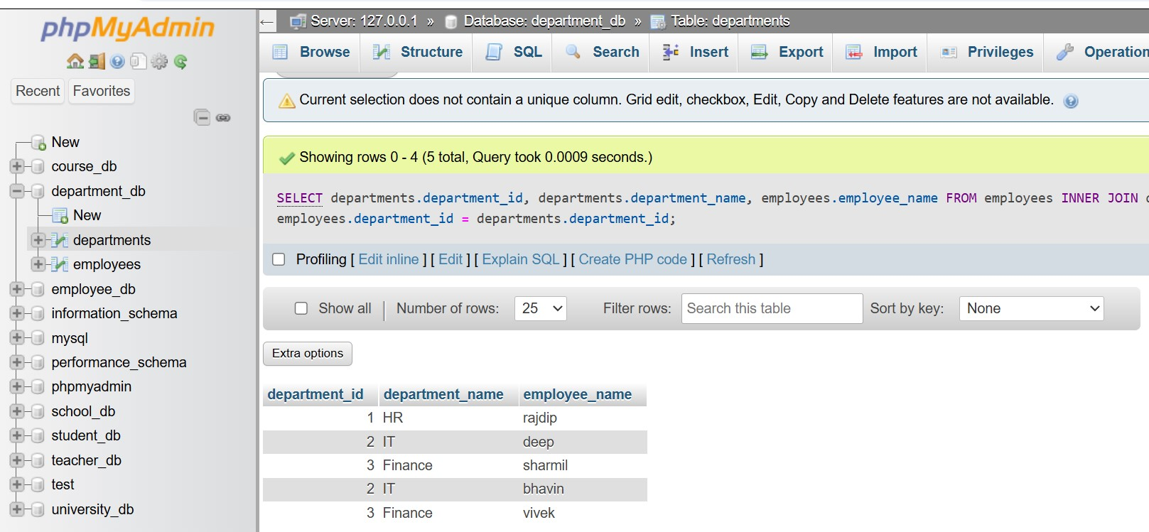

Lab 2: Use a LEFT JOIN to show all departments, even those without employees.

Ans.

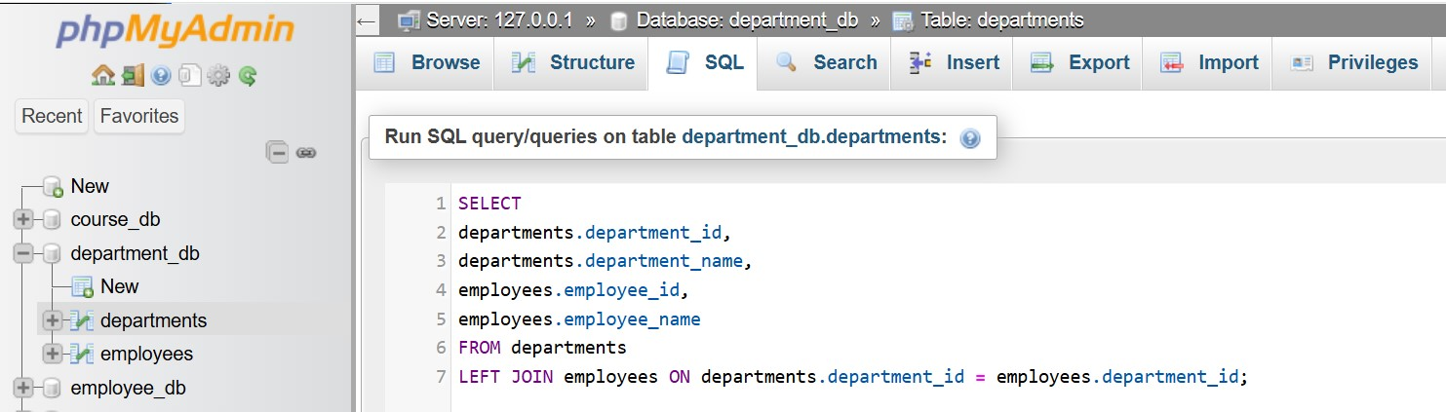

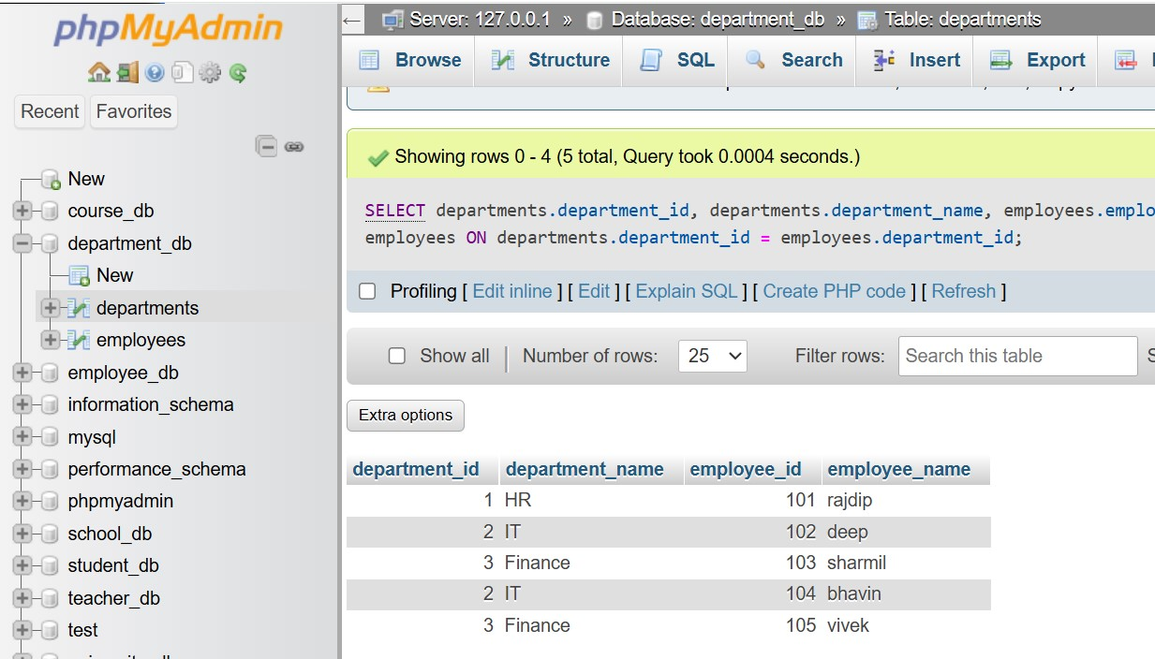

12. SQL Group By

Theory Questions:

1. What is the GROUP BY clause in SQL? How is it used with aggregate functions?

Ans.

GROUP BY Clause:

Groups those rows that have the same values into summary rows.

It collects data from multiple records and groups the results by one or more columns.

SELECT department, COUNT(name)

FROM employees

GROUP BY department;

It is often used with aggregate functions to perform calculations on each group.

Basic syntax:

SELECT column_name, AGGREGATE_FUNCTION(column_name)

FROM table_name

GROUP BY column_name;

|  |  |
| --- | --- |
| Aggregate Function | Description |
| COUNT(*) | Counts the number of rows in each group |
| SUM(column) | Calculates the total sum of values in each group |
| AVG(column) | Finds the average value in each group |
| MAX(column) | Finds the highest value in each group |
| MIN(column) | Finds the lowest value in each group |

2. Explain the difference between GROUP BY and ORDER BY.

Ans.

|  |  |  |
| --- | --- | --- |
| feature | GROUP BY | ORDER BY |
| Purpose | Groups rows based on shared values in a column | Sorts rows in ascending (ASC) or descending (DESC) order |
| Usage | Used with aggregate functions (SUM(), COUNT(), AVG(), etc.) | Used to sort final query results |
| Result | Returns one row per group | Returns all rows sorted |
| Aggregate Function | Yes, when selecting non-grouped columns | No, can sort without aggregation |
| Filters Applied | Can use HAVING to filter groups | Can use WHERE to filter rows before sorting |

LAB EXERCISES:

Lab 1: Group employees by department and count the number of employees in each department using GROUP BY.

Ans.

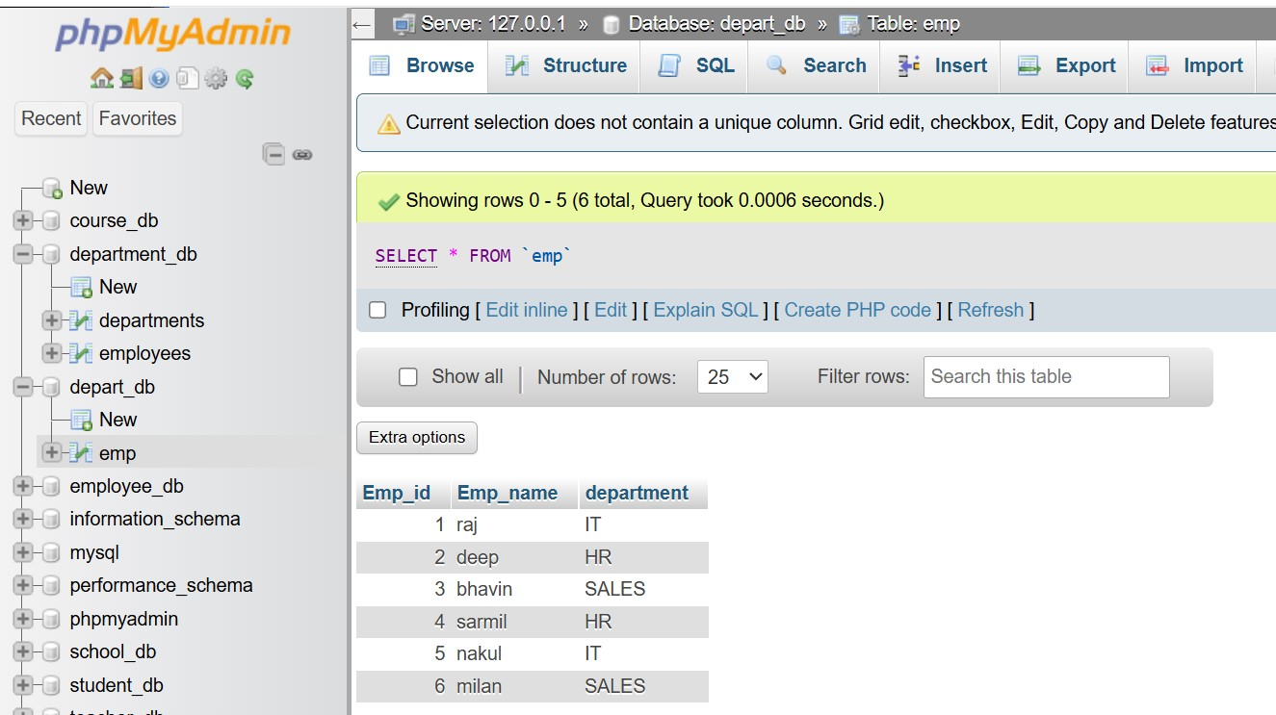

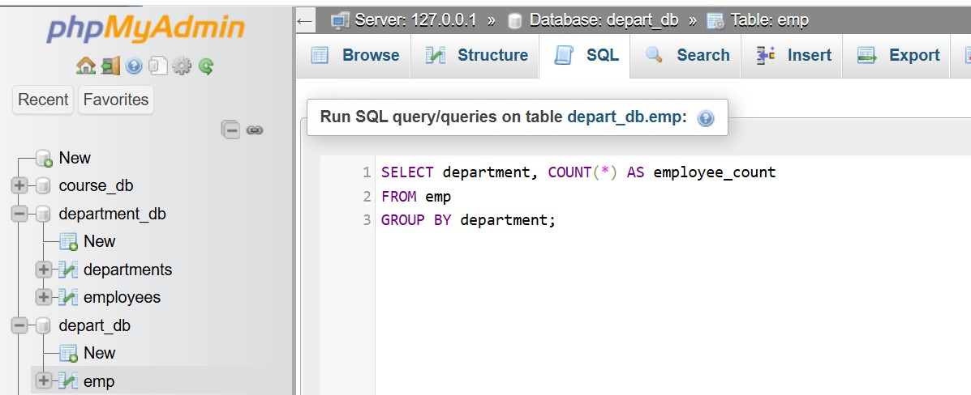

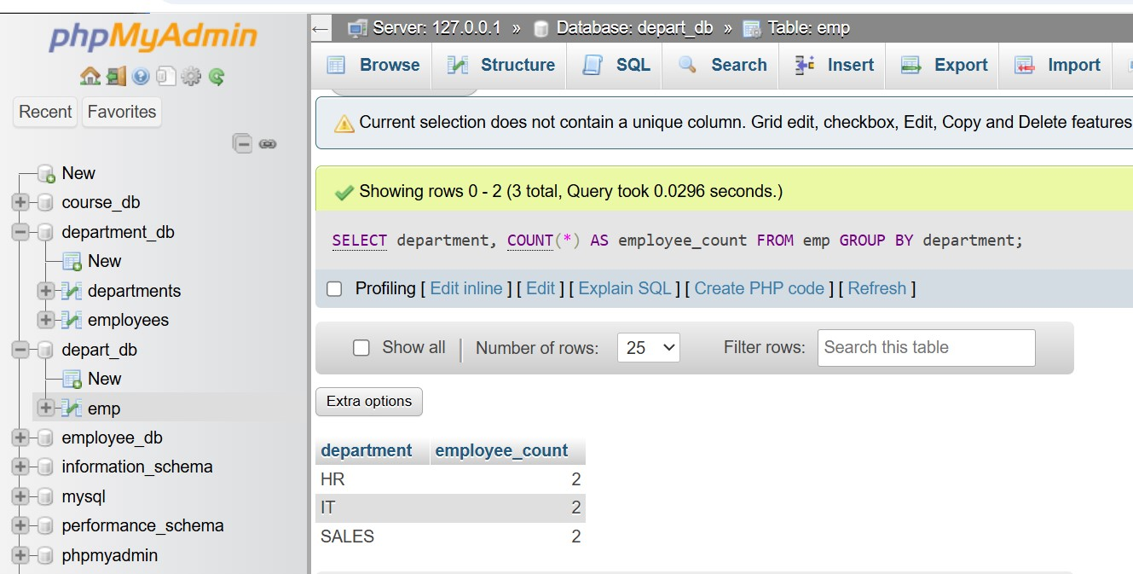

Lab 2: Use the AVG aggregate function to find the average salary of employees in each department.

Ans.

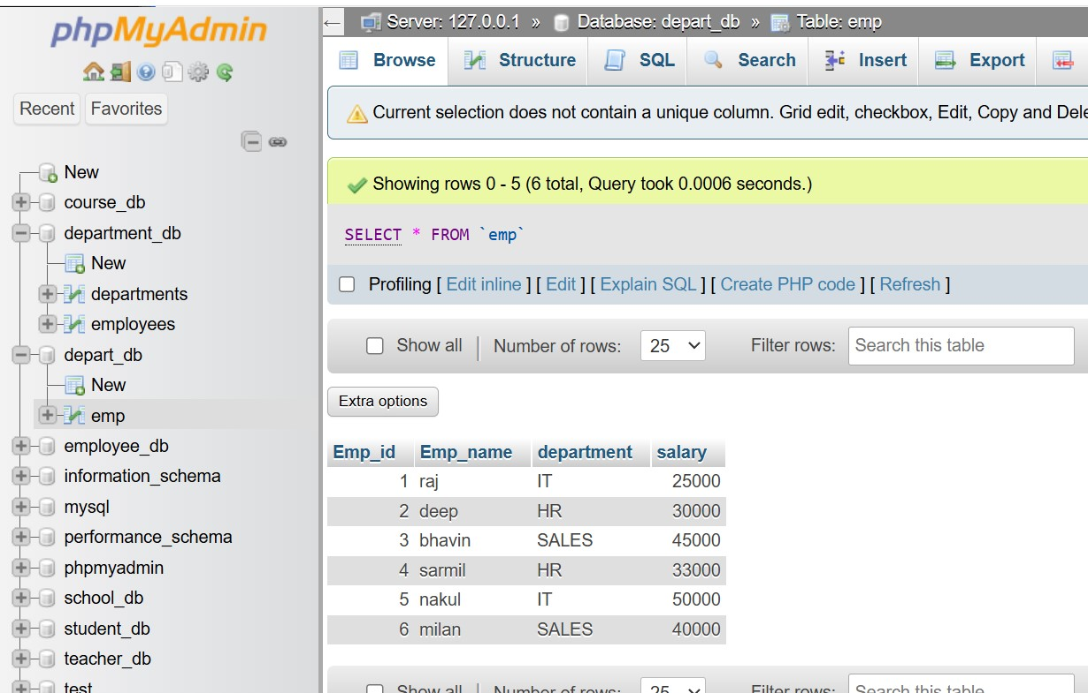

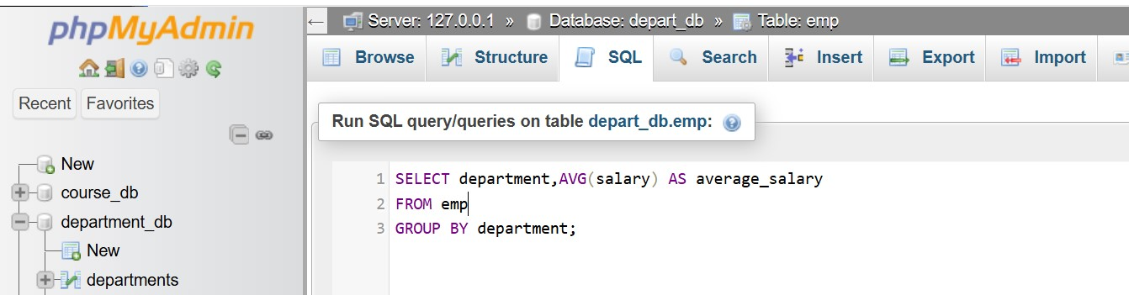

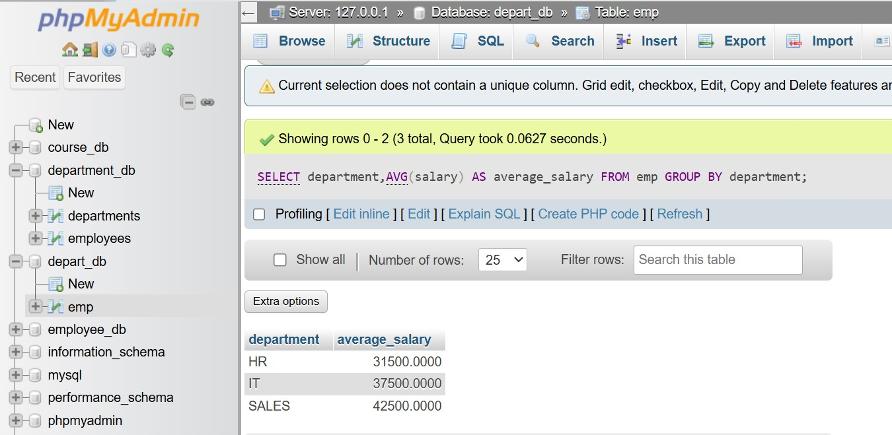

13. SQL Stored Procedure

Theory Questions:

1. What is a stored procedure in SQL, and how does it differ from a standard SQL query?

Ans.

What is a Stored Procedure?

It can contain multiple SQL statements, including SELECT, INSERT, UPDATE, DELETE, and even conditional logic.

Stored procedures are faster, reusable, and more secure than standard SQL queries.

Syntax:

CREATE PROCEDURE procedure_name

AS

BEGIN

-- SQL statements

END;

Standard SQL Query (One-Time Execution):

Standard SQL queries are best for quick one-time operations.

Example:

SELECT employee_id, name, salary

FROM employees

WHERE department = 'HR';

Runs once and retrieves HR employees.

Must be rewritten to query a different department.

2. Explain the advantages of using stored procedures.

Ans.

It can contain multiple SQL statements, including SELECT, INSERT, UPDATE, DELETE, and even conditional logic.

Stored procedures are faster, reusable, and more secure than standard SQL queries.

Syntax:

CREATE PROCEDURE procedure_name

AS

BEGIN

-- SQL statements

END;

Advantages:

Performance: Faster execution due to pre-compilation.

Reusability: Avoids rewriting queries, making code cleaner.

Security: Limits table access, preventing unauthorized data exposure.

Reduced Traffic: Sends only procedure calls, reducing network load.

Transaction Control: Ensures data consistency with COMMIT and ROLLBACK.

Modular Code: Organizes logic inside the database.

Scalability: Handles large workloads efficiently.

LAB EXERCISES:

Lab 1: Write a stored procedure to retrieve all employees from the employee's table based on department.

Ans.

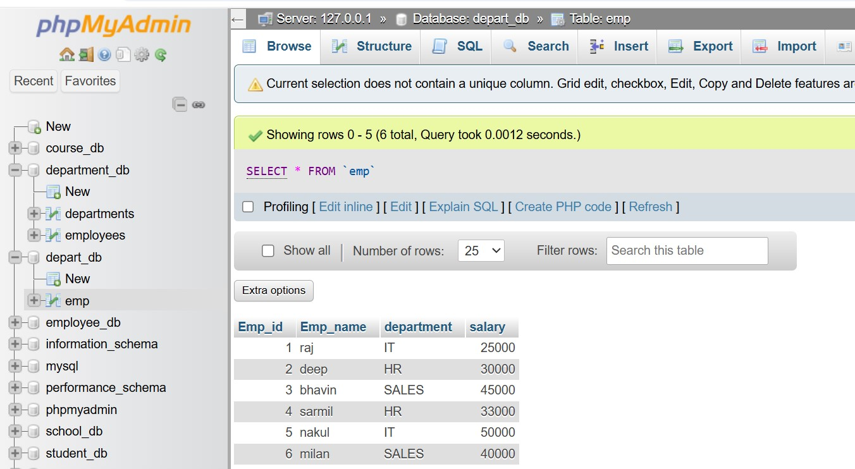

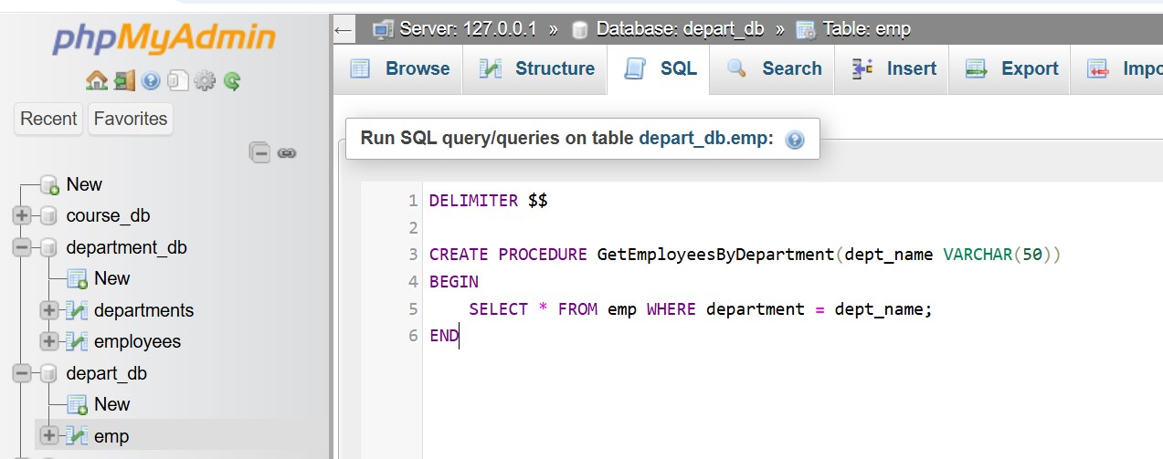

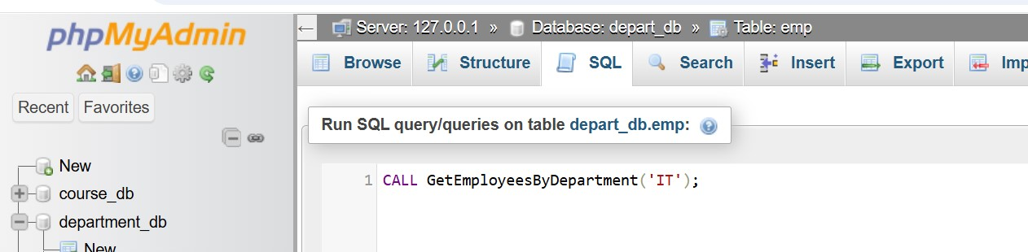

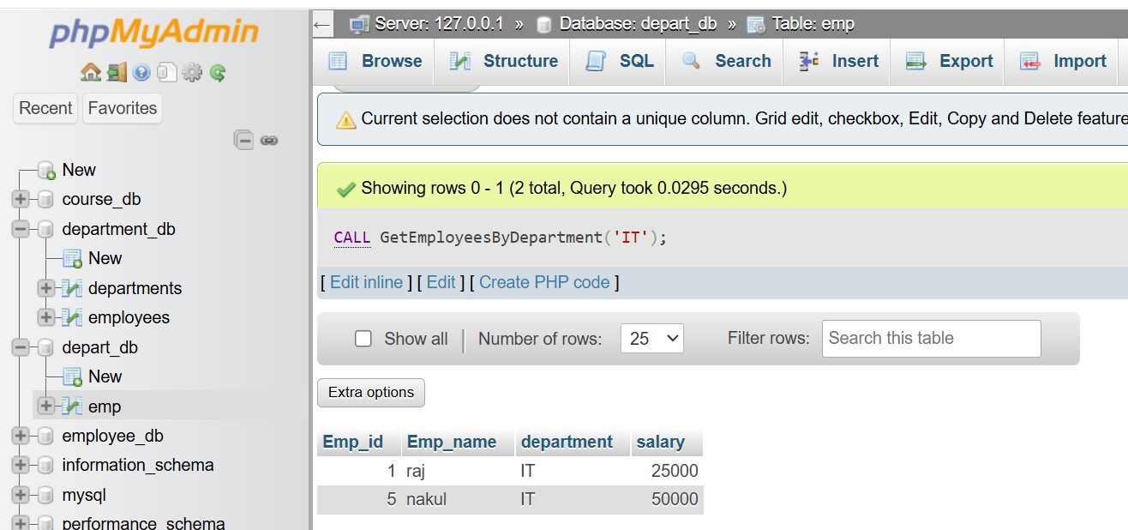

Lab 2: Write a stored procedure that accepts course_id as input and returns the course details.

Ans.

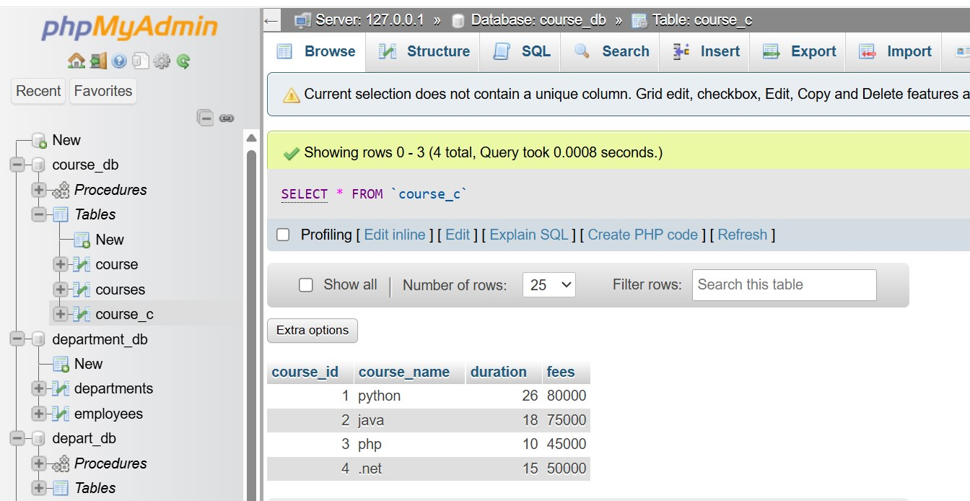

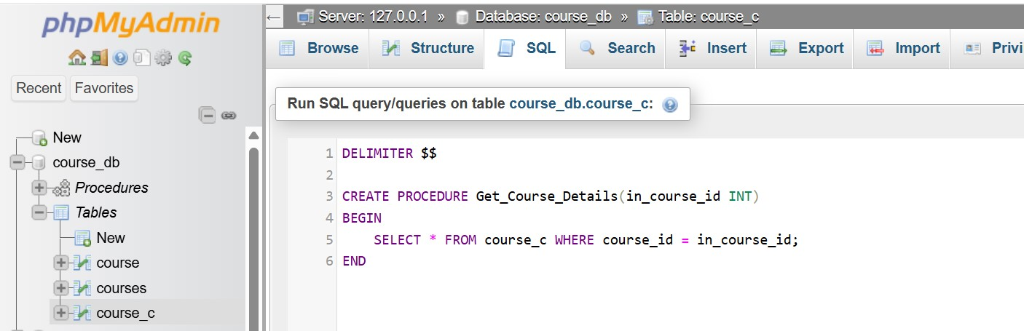

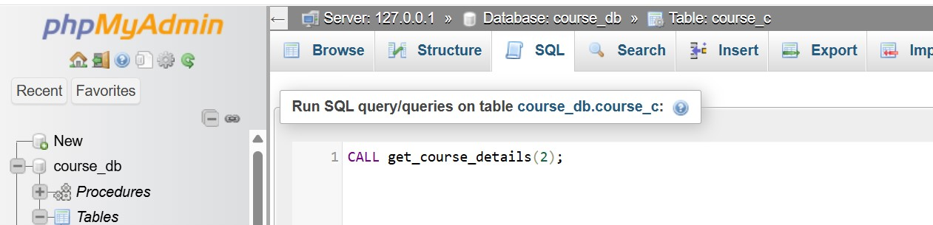

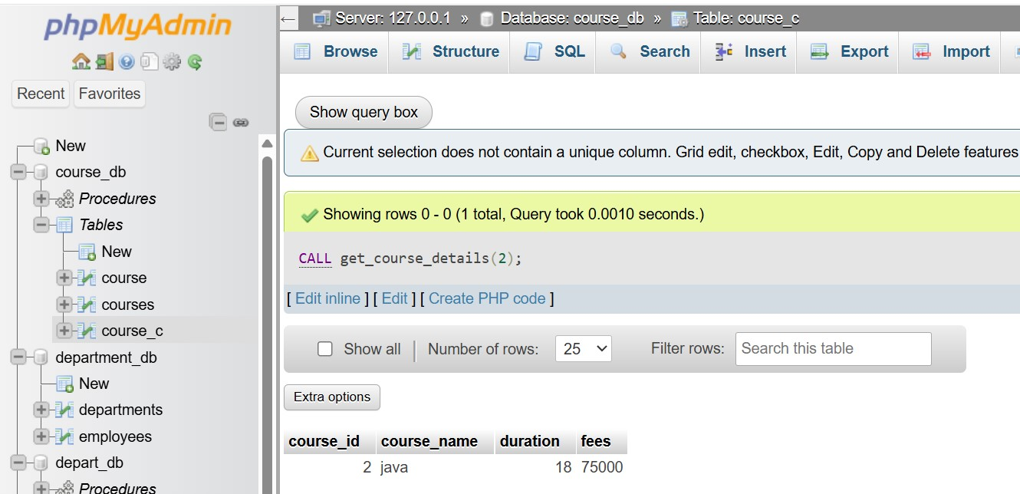

14. SQL View

Theory Questions:

1. What is a view in SQL, and how is it different from a table?

Ans.

What is a View?

A view is a virtual table in SQL that is created using a SELECT query.

It does not store data physically but dynamically retrieves it from one or more tables when accessed.

|  |  |  |
| --- | --- | --- |
| feature | View | Table |
| Definition | A stored SQL query that acts like a virtual table | A physical storage structure that holds actual data |
| Storage | Does not store data; only the query is stored | Stores data physically in the database |
| Data Updates | Can be updated | Can always be updated |
| Performance | Can be slower as it executes the query each time | Faster as data is pre-stored |
| Use Case | Used for simplifying complex queries, security, and abstraction | Used for storing and managing data |

2. Explain the advantages of using views in SQL databases.

Ans.

Views in SQL offer several benefits, making them a powerful tool for data security, simplification, and reusability.

Advantages of Using Views in SQL Databases:

Security & Access Control.

Simplifies Complex Queries.

Improves Maintainability.

Saves Storage Space.

Enhances Read Performance.

Provides Logical Independence.

Supports Aggregation & Reporting.

LAB EXERCISES:

Lab 1: Create a view to show all employees along with their department names.

Ans.

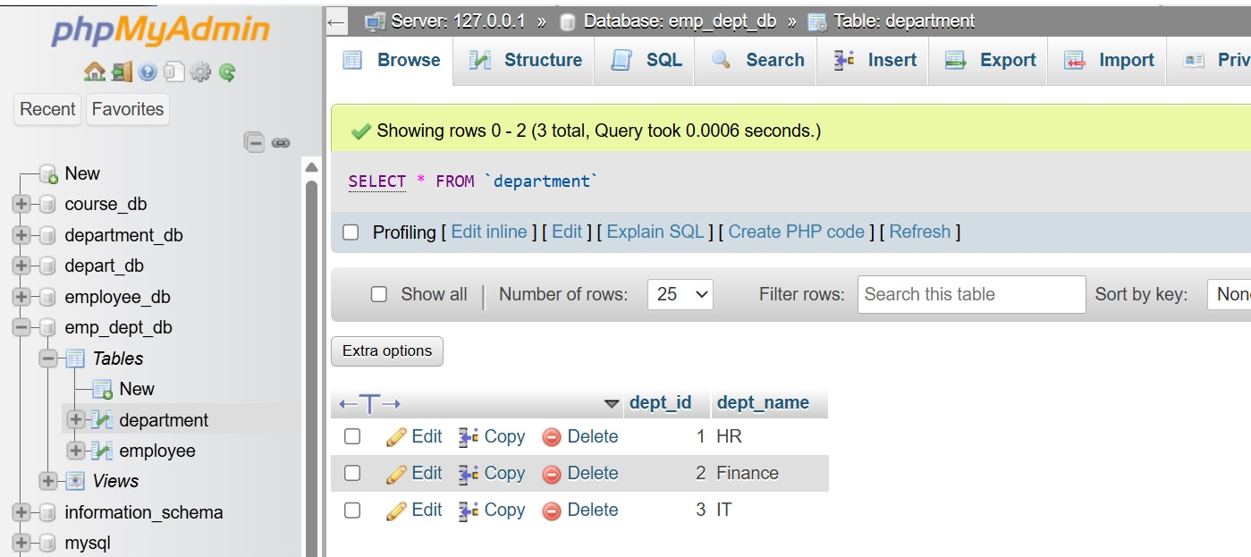

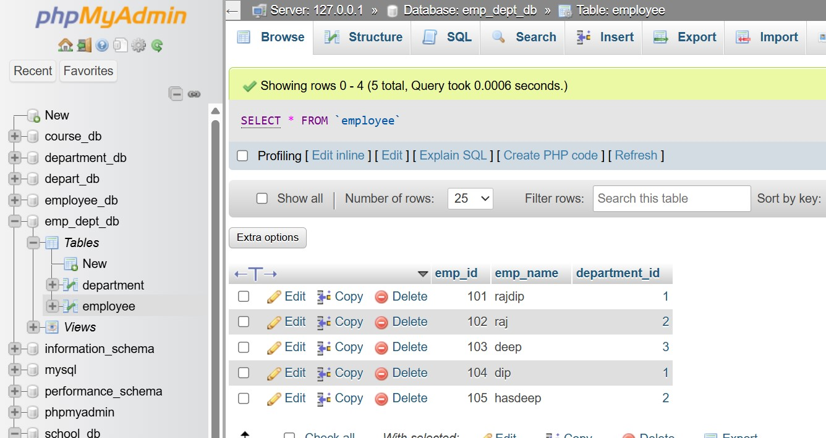

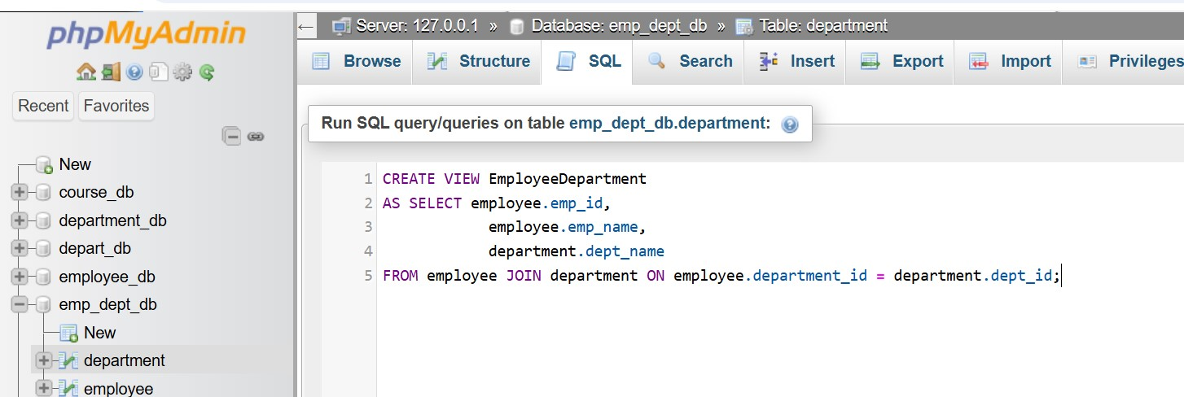

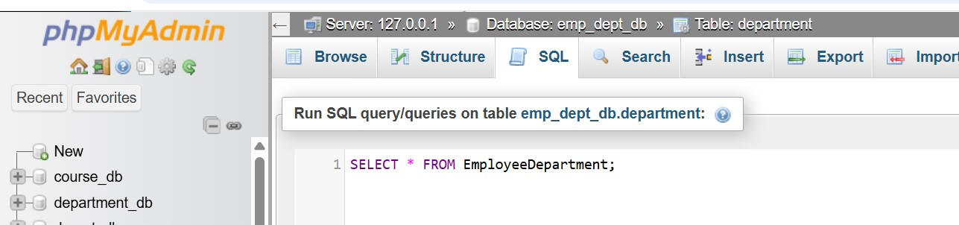

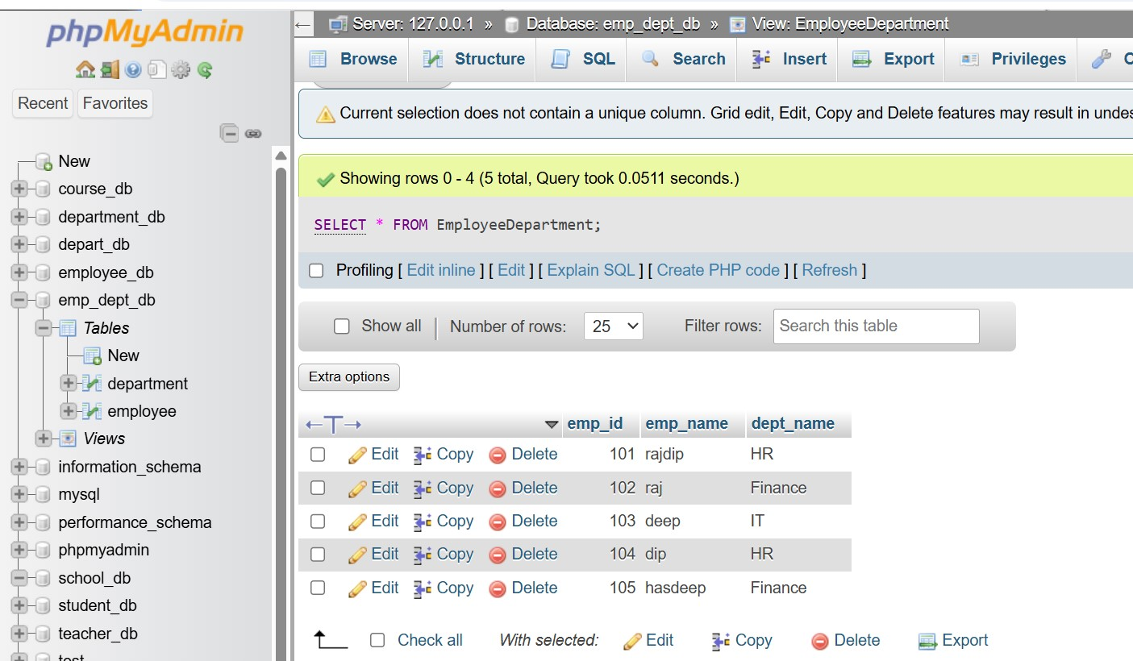

Lab 2: Modify the view to exclude employees whose salaries are below $50,000.

Ans.

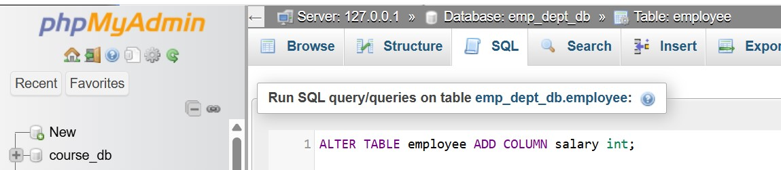

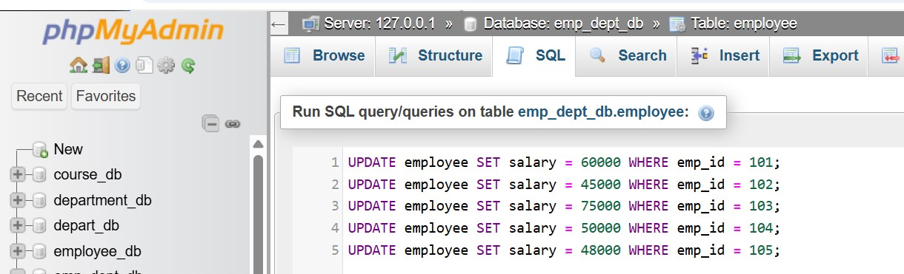

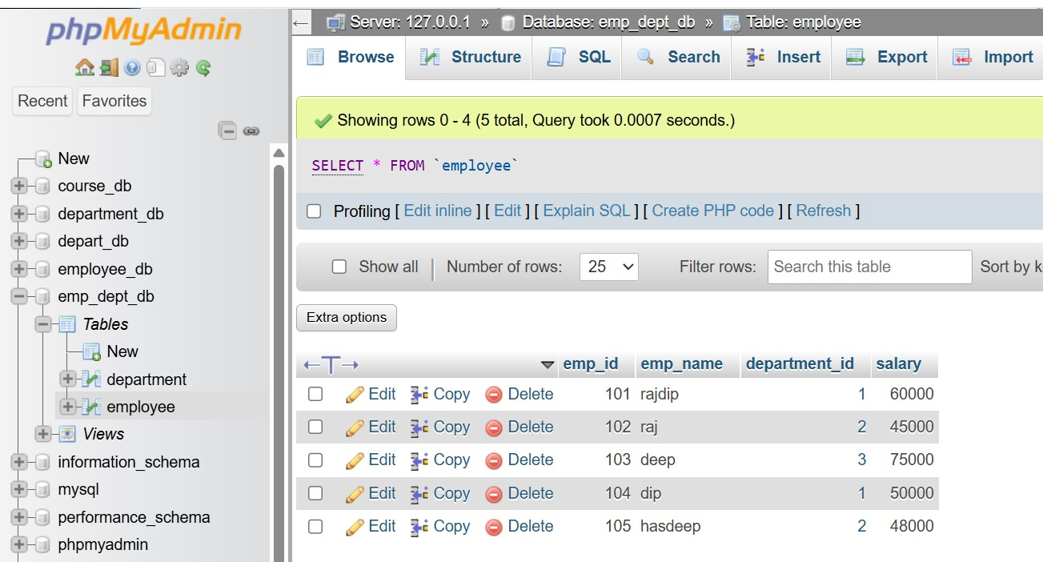

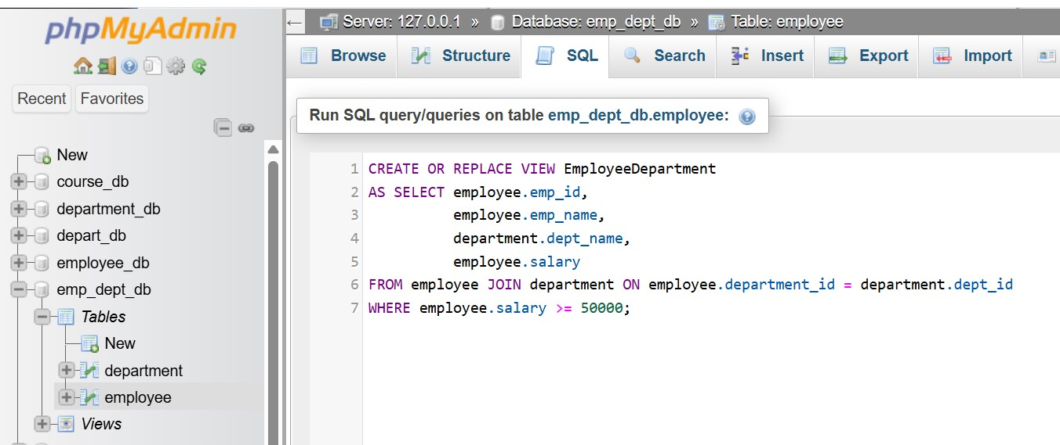

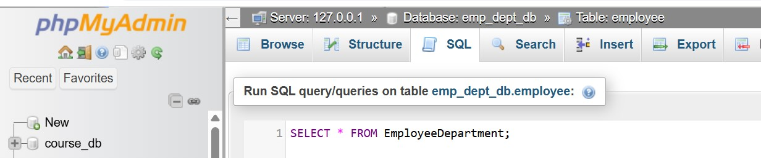

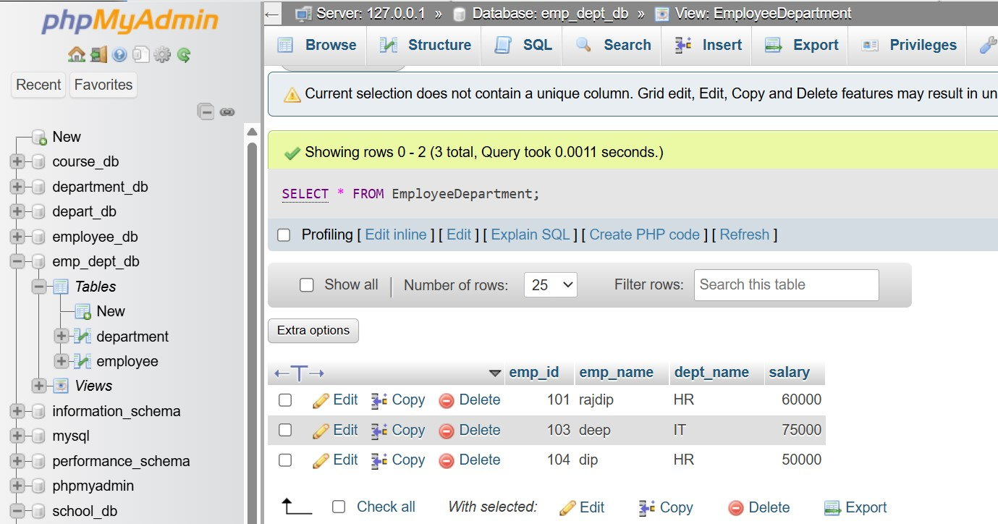

15. SQL Triggers

Theory Questions:

1. What is a trigger in SQL? Describe its types and when they are used.

Ans.

What is a Trigger in SQL?

A trigger is a special type of stored procedure in SQL that automatically executes in response to specific events on a table (such as INSERT, UPDATE, or DELETE).

1. BEFORE Trigger (Pre-Trigger):

Executes before the event (INSERT, UPDATE, DELETE) happens.  
Used to validate data before modifying the table.

2. AFTER Trigger (Post-Trigger):

Executes after the event (INSERT, UPDATE, DELETE) occurs.  
Used to log changes, update related tables, or maintain audit records.

3. INSTEAD OF Trigger:

Used on views where INSERT, UPDATE, or DELETE operations are not directly possible.  
Allows updates on virtual tables (views) by redirecting operations to base tables.

2. Explain the difference between INSERT, UPDATE, and DELETE triggers.

Ans.

1. INSERT Trigger:

Fires when a new record is inserted into a table.  
Used to validate data, log new entries, or modify inserted values before they are saved.

INSERT triggers handle new data entries.

2. UPDATE Trigger:

Fires when an existing record is updated in a table.  
Used to track changes, enforce constraints, or update related tables.

UPDATE triggers track modifications to existing records.

3. DELETE Trigger:

Fires when a record is deleted from a table.  
Used to prevent accidental deletions, maintain audit logs, or enforce business rules.

DELETE triggers manage data removal, preventing accidental loss.

LAB EXERCISES:

Lab 1: Create a trigger to automatically log changes to the employee's table when a new employee is added.

Ans.

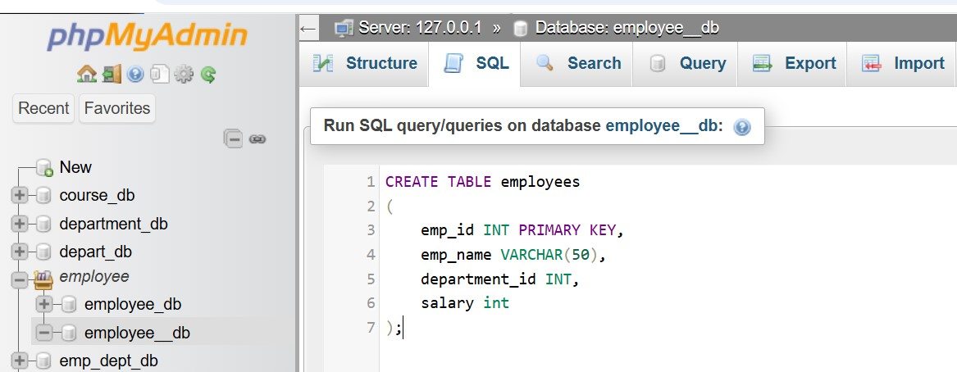

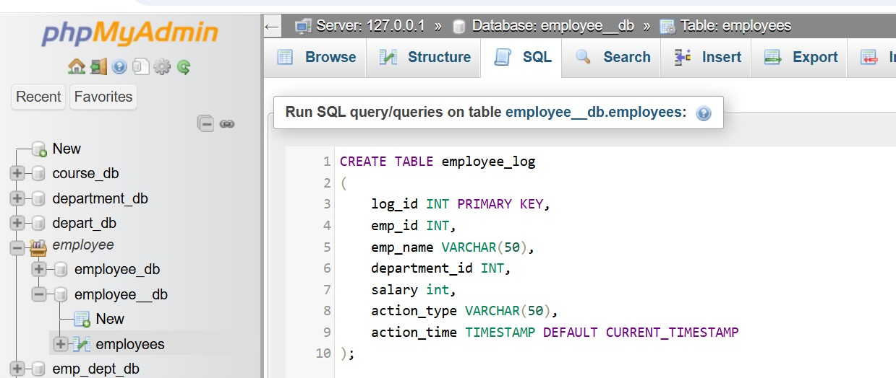

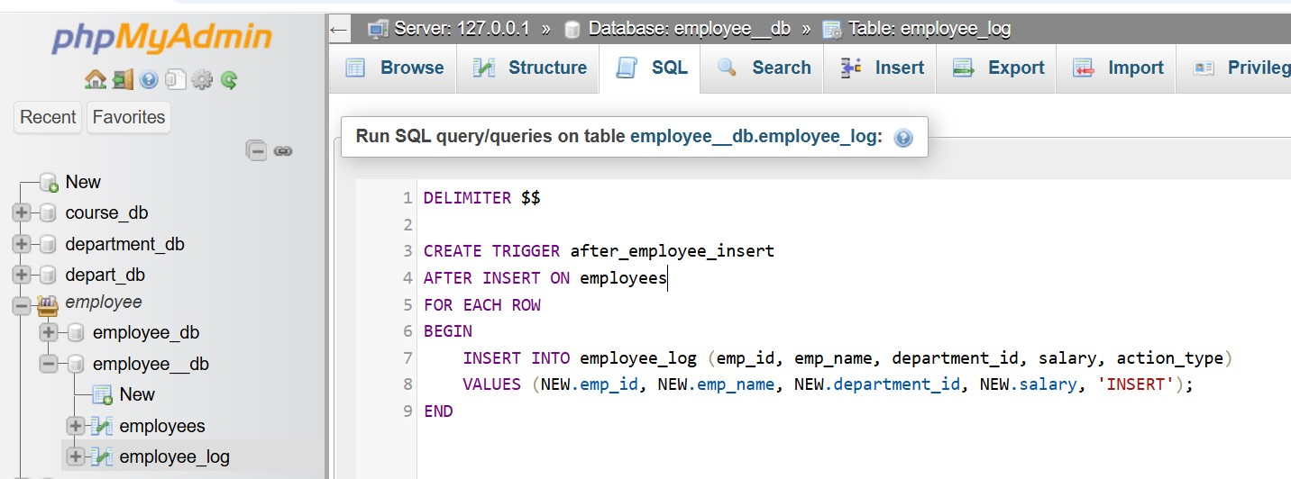

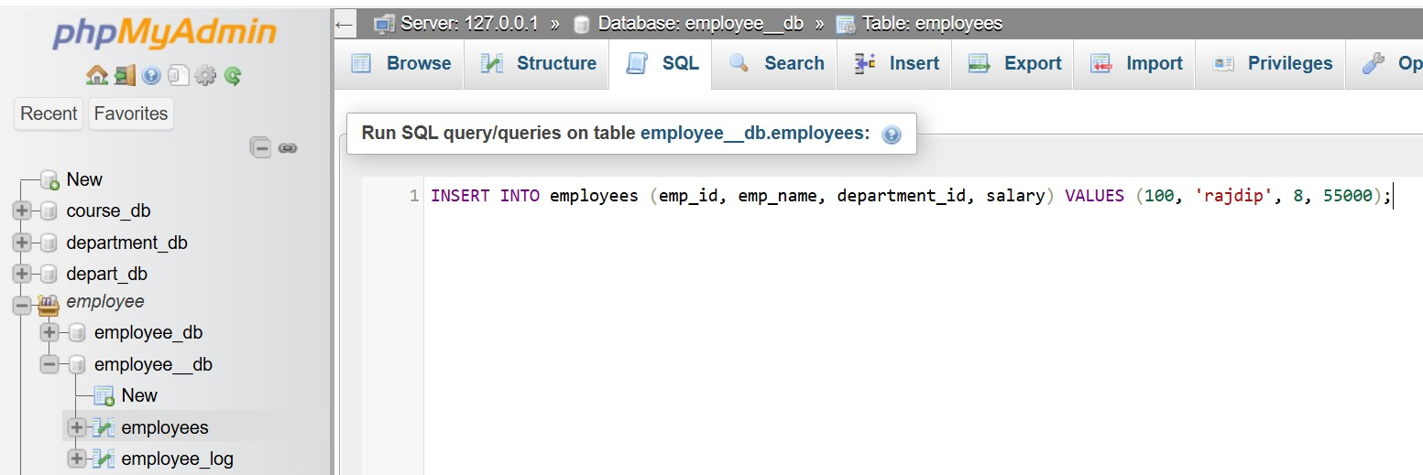

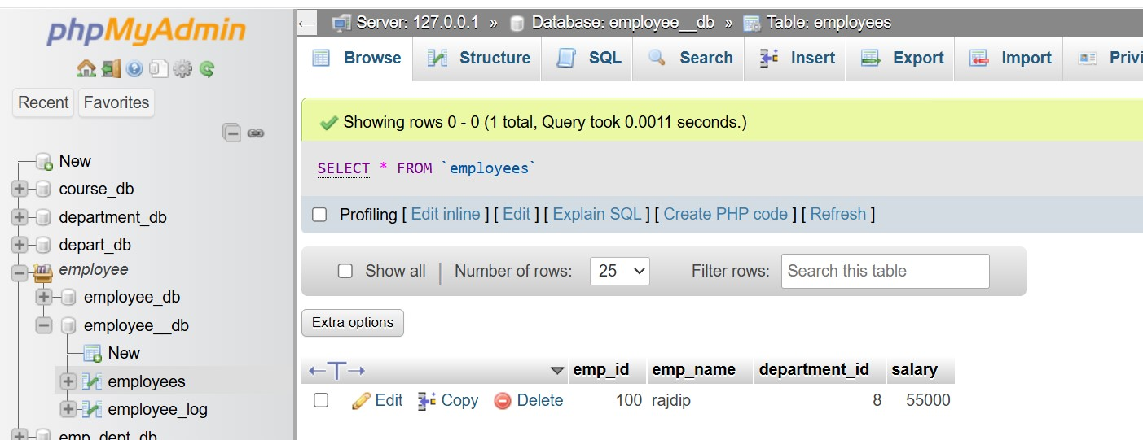

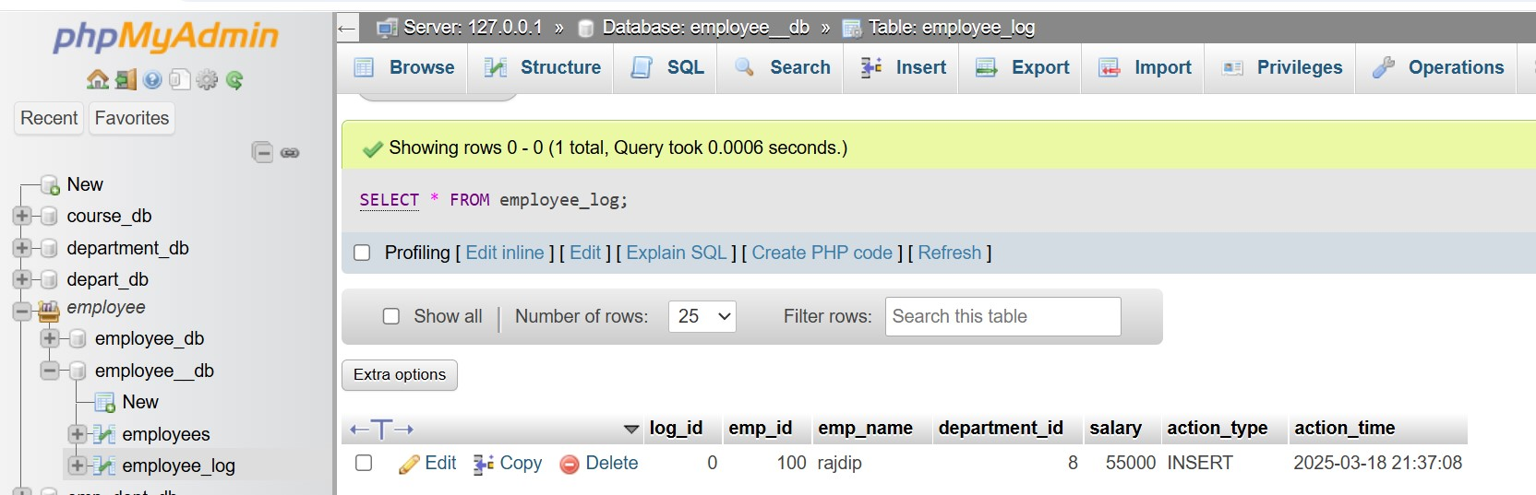

Lab 2: Create a trigger to update the last_modified timestamp whenever an employee record is updated.

Ans.

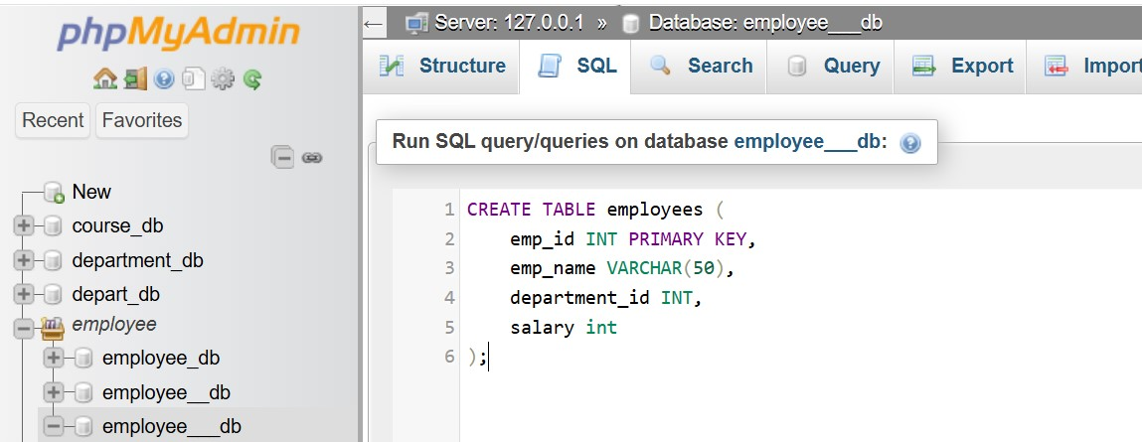

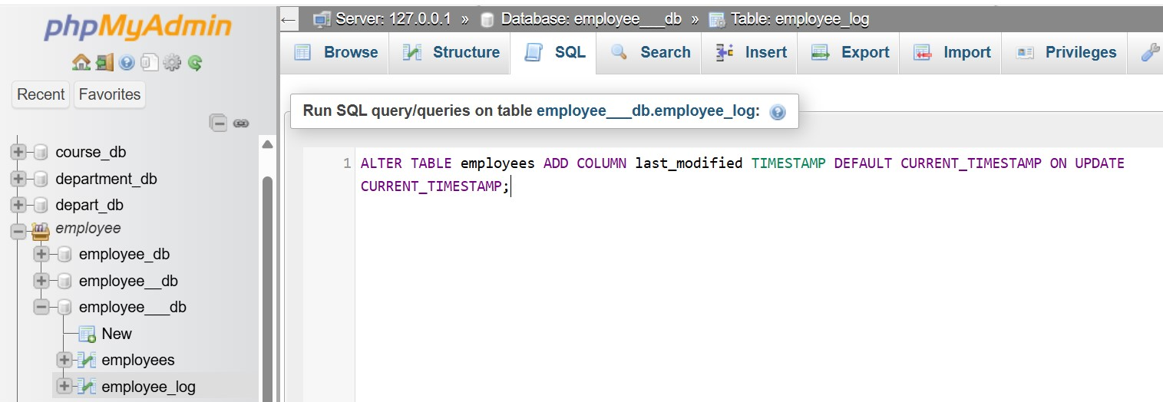

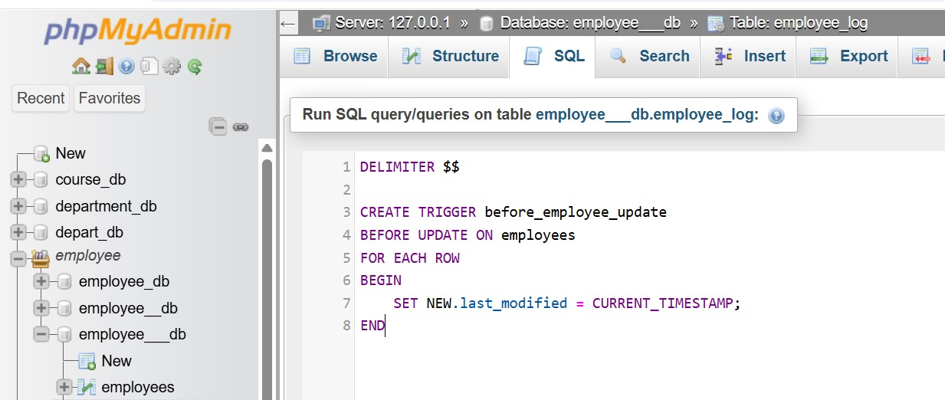

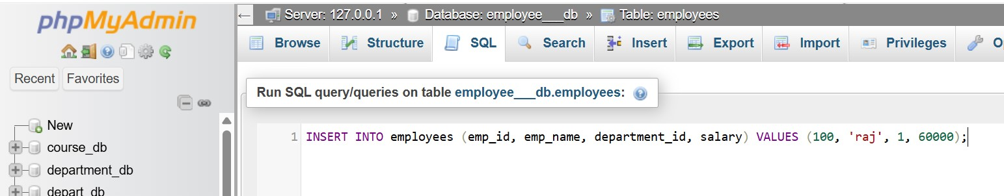

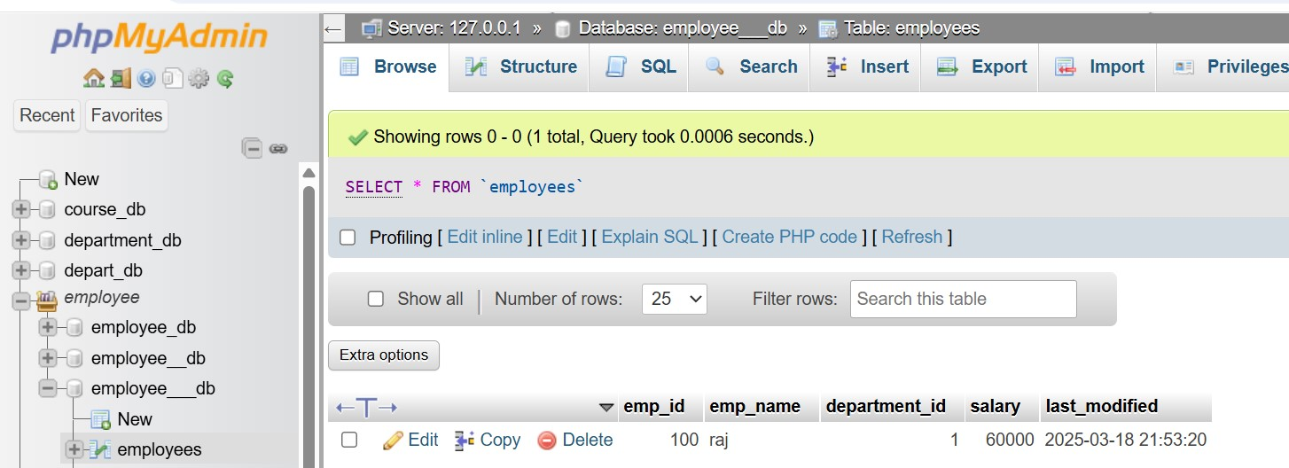

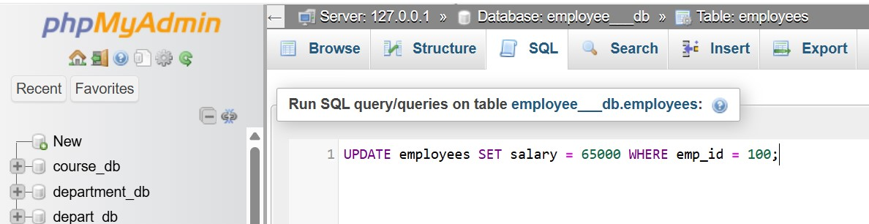

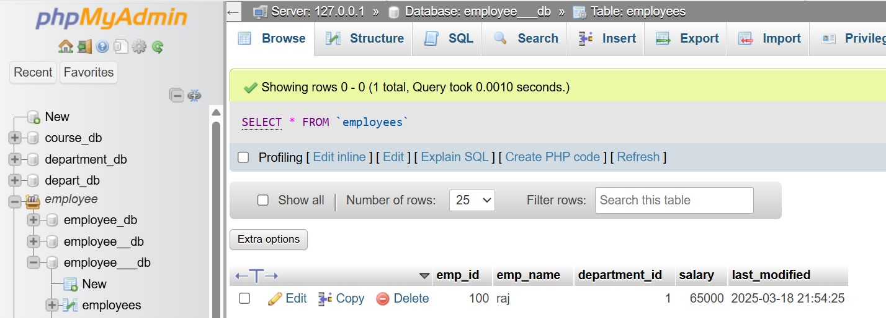

16. Introduction to PL/SQL

Theory Questions:

1. What is PL/SQL, and how does it extend SQL's capabilities?

Ans.

What is PL/SQL:

PL/SQL (Procedural Language/Structured Query Language).

How PL/SQL Extends SQL's Capabilities:

|  |  |  |
| --- | --- | --- |
| feature | SQL | PL/SQL |
| Query Execution | Executes single SQL statements (e.g., SELECT, INSERT) | Executes multiple SQL statements within a block |
| Procedural Logic | Not supported | Supports loops, conditions (IF), and error handling |
| Stored Procedures & Functions | Not available in pure SQL | Allows creation of stored procedures & functions |
| Exception Handling | No built-in handling for errors | Supports structured error handling |
| Triggers & Cursors | Limited | Supports triggers & cursors for advanced data manipulation |
| Performance | Executes queries one at a time | Reduces network traffic by processing multiple statements together |

2. List and explain the benefits of using PL/SQL.

Ans.

PL/SQL (Procedural Language/Structured Query Language).

PL/SQL Benefits:

Performance Optimization.

Code Reusability & Modularity.

Procedural Logic.

Exception Handling.

Security & Access Control.

Triggers for Automation.

Efficient Data Handling.

Reduces Application Load.

LAB EXERCISES:

Lab 1: Write a PL/SQL block to print the total number of employees from the employee's table.

Ans.

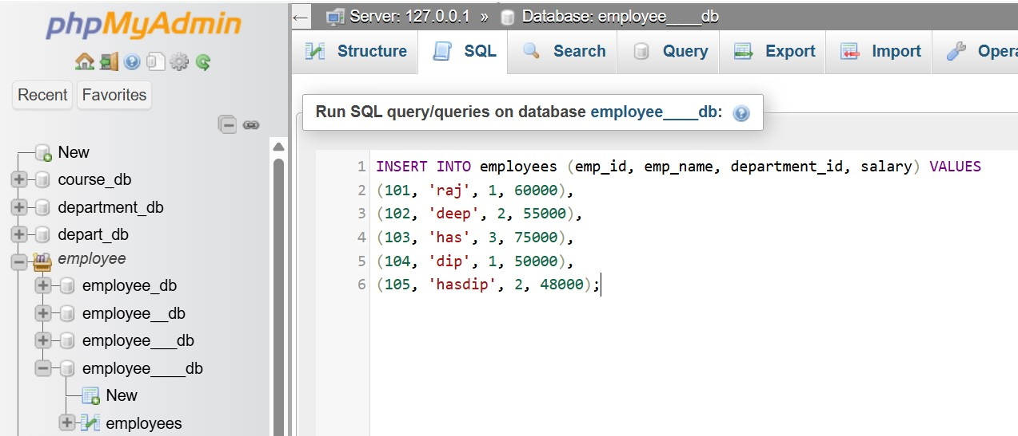

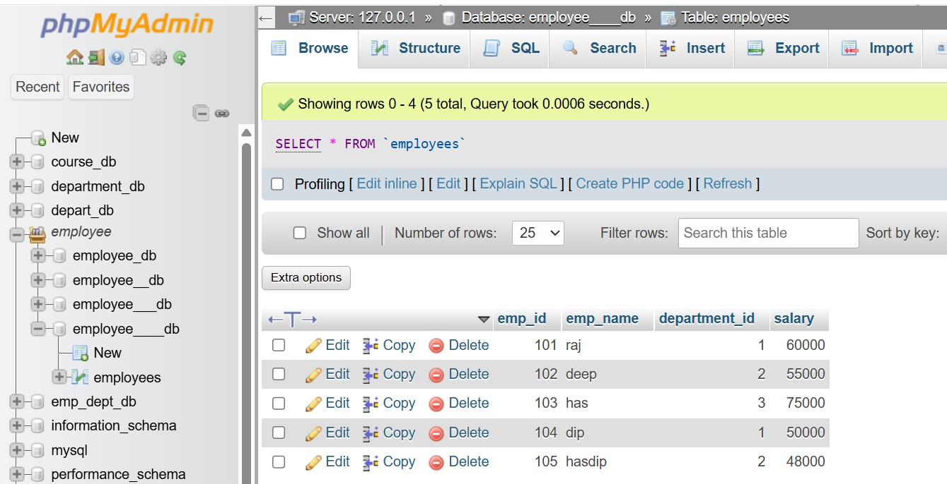

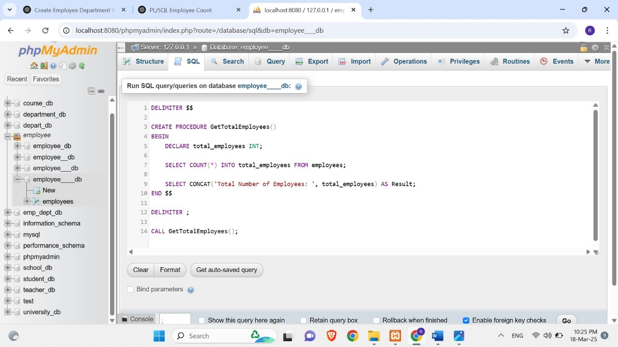

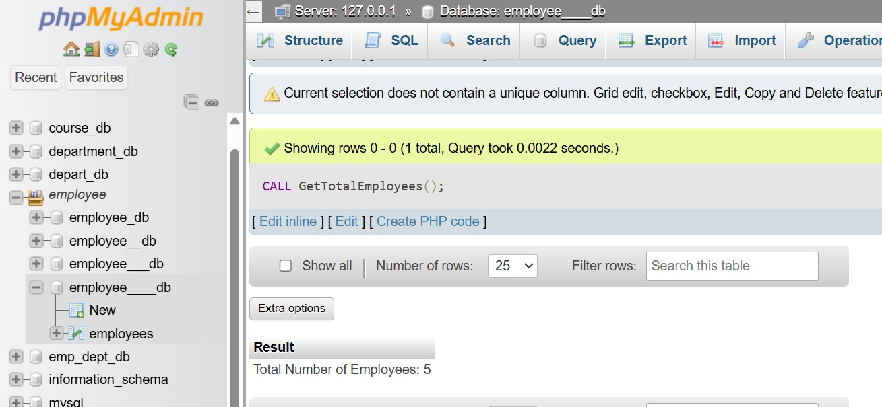

Lab 2: Create a PL/SQL block that calculates the total sales from an orders table.

Ans.

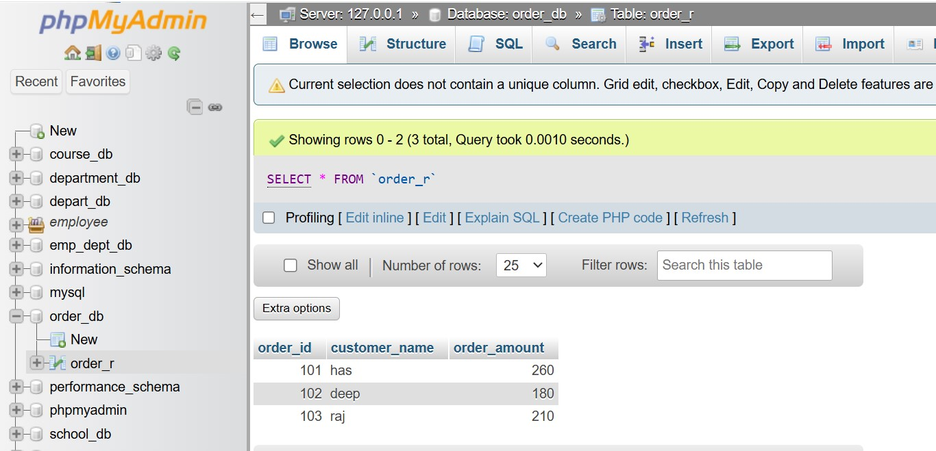

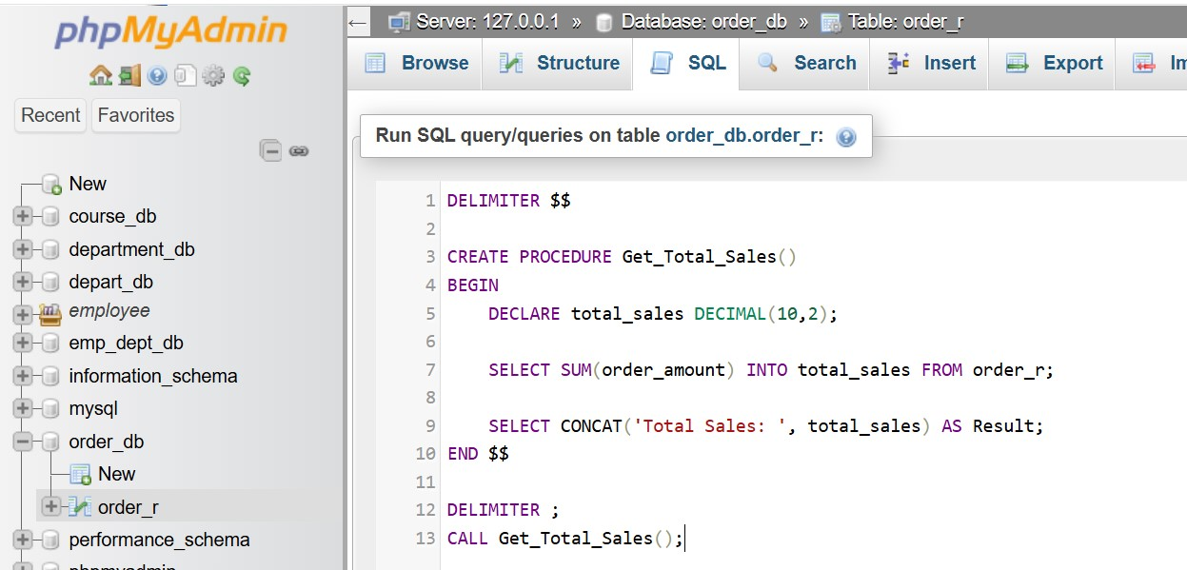

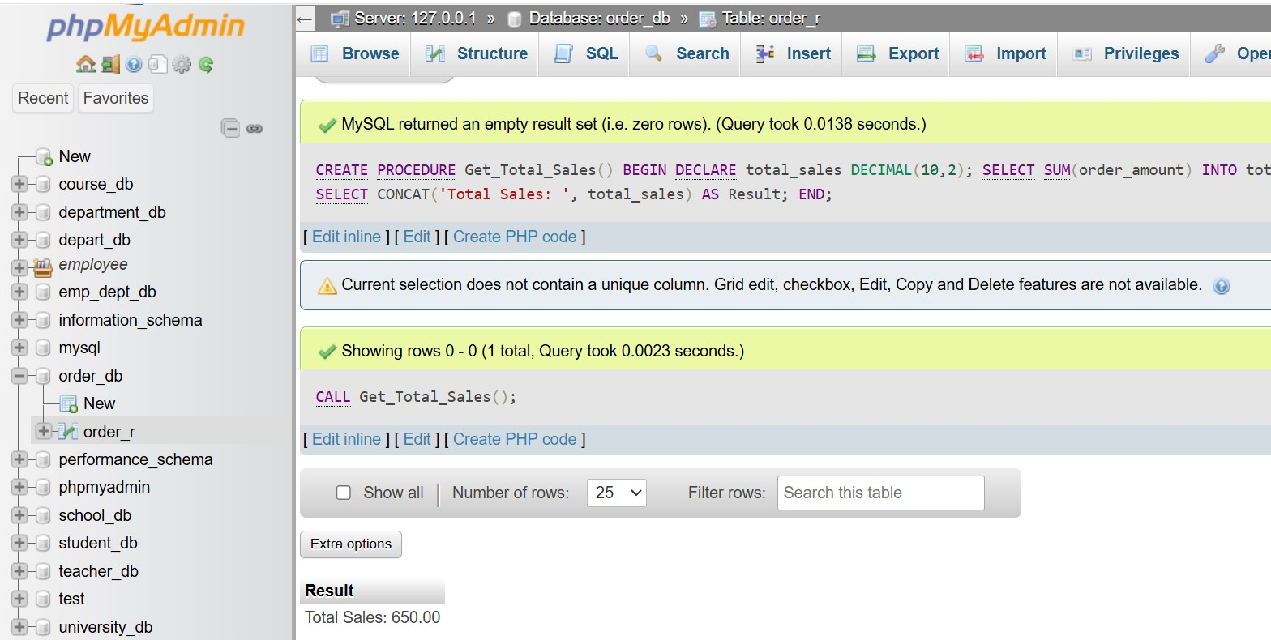

17. PL/SQL Control Structures

Theory Questions:

1. What are control structures in PL/SQL? Explain the IF-THEN and LOOP control structures.

Ans.

Control structures in PL/SQL control the flow of execution within a program.

There are three types of control structures:

1. Conditional Statements – (IF-THEN, IF-THEN-ELSE, CASE)
2. Looping Statements – (LOOP, WHILE LOOP, FOR LOOP)
3. Sequential Control – (GOTO, EXIT).

1. IF-THEN Control Structure:

The IF-THEN structure executes a block of code only if a condition is TRUE.

Syntax:

IF condition THEN

-- Code to execute if the condition is TRUE

END IF;

2. LOOP Control Structure (Repeated Execution):

Loops repeat a block of code multiple times until a condition is met.

Types of Loops in PL/SQL:

1. Simple LOOP – Runs indefinitely until explicitly exited.
2. WHILE LOOP – Runs as long as a condition is TRUE.
3. FOR LOOP – Runs a fixed number of times.

Simple loop syntax:

LOOP

-- Code to execute repeatedly

EXIT WHEN condition;

END LOOP;

2. How do control structures in PL/SQL help in writing complex queries?

Ans.

Why Use Control Structures in Complex Queries:

|  |  |
| --- | --- |
| feature | benefit |
| Conditional Logic (IF-THEN, CASE) | Customizes execution based on conditions |
| Looping (LOOP, FOR, WHILE) | Automates bulk data processing |
| Cursors | Processes multiple rows efficiently |
| Triggers | Automates data integrity & auditing |
| Exception Handling (EXCEPTION) | Prevents query failures & logs errors |

LAB EXERCISES:

Lab 1: Write a PL/SQL block using an IF-THEN condition to check the department of an employee.

Ans.

DECLARE

v_employee_id NUMBER := 101;

v_department_id NUMBER;

BEGIN

SELECT department_id INTO v_department_id

FROM employees

WHERE employee_id = v_employee_id;

IF v_department_id = 10 THEN

DBMS_OUTPUT.PUT_LINE('Employee ' || v_employee_id || ' works in the HR department.');

ELSIF v_department_id = 20 THEN DBMS_OUTPUT.PUT_LINE('Employee ' || v_employee_id || ' works in the Sales department.');

ELSE DBMS_OUTPUT.PUT_LINE('Employee ' || v_employee_id || ' works in another department.');

END IF;

END;

Lab 2: Use a FOR LOOP to iterate through employee records and display their names.

Ans.

DECLARE

CURSOR emp_cursor IS

SELECT employee_id, first_name, last_name FROM employees;

BEGIN FOR emp_rec IN emp_cursor LOOP

DBMS_OUTPUT.PUT_LINE('Employee ID: ' || emp_rec.employee_id || ', Name: ' || emp_rec.first_name || ' ' || emp_rec.last_name);

END LOOP;

END;

18. SQL Cursors

Theory Questions:

1. What is a cursor in PL/SQL? Explain the difference between implicit and explicit cursors.

Ans.

What is a Cursor in PL/SQL?

A cursor in PL/SQL is a pointer to a result set that allows you to retrieve and process multiple rows from a query one at a time.

Key Differences: Implicit vs. Explicit Cursors:

|  |  |  |
| --- | --- | --- |
| Feature | Implicit cursors | Explicit cursors |
| Declaration | No need (automatically created) | Must be explicitly declared |
| Control | Managed by PL/SQL | User controls opening, fetching, and closing |
| Usage | Used for single-row queries | Used for multi-row queries |
| Performance | More efficient for single-row operations | Better for handling multiple rows |
| Example | SELECT INTO, INSERT, UPDATE, DELETE. | SELECT returning multiple rows |

2. When would you use an explicit cursor over an implicit one?

Ans.

You should use an explicit cursor instead of an implicit one when you need fine control over multi-row queries.

While implicit cursors are automatically managed, explicit cursors allow row-by-row processing, making them ideal for complex data operations.

Explicit cursors allow you to OPEN, FETCH, and CLOSE the result set manually.

Explicit cursors can lock rows to prevent changes by other transactions.

explicit cursor allows row-by-row processing.

When to Use Explicit vs. Implicit Cursors:

|  |  |  |
| --- | --- | --- |
| feature | Explicit cursors | Implicit cursors |
| Single-row queries | Yes | No |
| Single-row queries | No | Yes |
| Loop through results | No | Yes |
| Row-by-row processing | No | Yes |
| Locking rows (FOR UPDATE) | No | Yes |

LAB EXERCISES:

Lab 1: Write a PL/SQL block using an explicit cursor to retrieve and display employee details.

Ans.

DECLARE

CURSOR emp_cursor IS

SELECT employee_id, first_name, last_name, department_id, salary

FROM employees;

emp_rec emp_cursor%ROWTYPE;

BEGIN OPEN emp_cursor;

LOOP FETCH emp_cursor INTO emp_rec;

EXIT WHEN emp_cursor%NOTFOUND;

DBMS_OUTPUT.PUT_LINE('Employee ID: ' || emp_rec.employee_id || ', Name: ' || emp_rec.first_name || ' ' || emp_rec.last_name || ', Department ID: ' || emp_rec.department_id || ', Salary: ' || emp_rec.salary);

END LOOP;

CLOSE emp_cursor;

END;

Lab 2: Create a cursor to retrieve all courses and display them one by one.

Ans.

DECLARE

CURSOR course_cursor IS

SELECT course_id, course_name, instructor FROM courses;

course_rec course_cursor%ROWTYPE;

BEGIN

OPEN course_cursor;

LOOP

FETCH course_cursor INTO course_rec;

EXIT WHEN course_cursor%NOTFOUND;

DBMS_OUTPUT.PUT_LINE('Course ID: ' || course_rec.course_id || ', Course Name: ' || course_rec.course_name || ', Instructor: ' || course_rec.instructor); END LOOP;

CLOSE course_cursor;

END;

19. Rollback and Commit Savepoint

Theory Questions:

1. Explain the concept of SAVEPOINT in transaction management. How do ROLLBACK and COMMIT interact with savepoints?

Ans.

Concept of SAVEPOINT in Transaction Management:

A SAVEPOINT in SQL is a marker inside a transaction that allows partial rollbacks.

It helps in managing complex transactions by letting you roll back only to a certain point instead of undoing the entire transaction.

How SAVEPOINT Works:

A transaction begins with INSERT, UPDATE, DELETE, or other SQL operations.

You create a SAVEPOINT at a specific stage in the transaction.

If an error occurs, you can roll back to SAVEPOINT instead of rolling back the entire transaction.

If everything is successful, you COMMIT the changes permanently.

How SAVEPOINT, COMMIT, and ROLLBACK Interact:

|  |  |
| --- | --- |
| command | function |
| SAVEPOINT savepoint_name | Creates a rollback point in the transaction. |
| ROLLBACK TO savepoint_name | Rolls back only to the savepoint (keeps changes before it). |
| COMMIT | Saves all changes permanently, removing all savepoints. |
| ROLLBACK | Undoes the entire transaction (ignores savepoints). |

2. When is it useful to use savepoints in a database transaction?

Ans.

When to Use SAVEPOINTs:

Handling Errors in Multi-Step Transactions:

If a transaction involves multiple operations, some parts may fail.

SAVEPOINTs allow you to roll back only the failed part instead of the whole transaction.

Preventing Total Data Loss in Batch Processing:

When updating or deleting a large number of records, SAVEPOINTs help avoid losing all changes if an error occurs in one part of the batch.

Nested Transactions:

When a transaction has multiple dependent steps, SAVEPOINTs allow rolling back only certain steps while continuing with the rest.

Key Benefits of Using SAVEPOINT:

Multi-step transactions: Allows partial rollbacks instead of restarting the entire transaction.

Batch processing: Prevents total data loss by rolling back only failed batches.

Error handling: Helps recover from failures in one part of the transaction.

Nested transactions: Maintains consistency while handling sub-transactions.

Performance optimization: Saves time by avoiding re-executing the entire transaction.

LAB EXERCISES:

Lab 1: Perform a transaction where you create a savepoint, insert records, and then roll back to the savepoint.

Ans.

INSERT INTO employees (employee_id, first_name, department_id, salary)

VALUES (5001, 'raj', 10, 50000);

SAVEPOINT before_insertion;

INSERT INTO employees (employee_id, first_name, department_id, salary)

VALUES (5002, 'deep', 20, 60000);

INSERT INTO employees (employee_id, first_name, department_id, salary) VALUES (5003, 'Alice', 30, 55000);

ROLLBACK TO before_insertion;

COMMIT;

Lab 2: Commit part of a transaction after using a savepoint and then roll back the remaining changes.

Ans.

INSERT INTO employees (employee_id, first_name, last_name, department_id, salary)

VALUES (6001, 'raj', 'chavda', 10, 55000);

SAVEPOINT before_more_inserts;

INSERT INTO employees (employee_id, first_name, last_name, department_id, salary)

VALUES (6002, 'deep', 'shah', 20, 60000);

INSERT INTO employees (employee_id, first_name, last_name, department_id, salary)

VALUES (6003, 'dip', 'Vyas', 30, 65000);

COMMIT;

ROLLBACK TO before_more_inserts;